Table of Contents

**JANUARY 2026 | STRATEGIC INTELLIGENCE**

**ANIMAL NUTRACEUTICALS**

The Wellness Market at an Inflection Point

*Mapping value creation across a $6 billion global industry  
driven by pet humanization and the post-antibiotic transition*

# **ANIMAL NUTRACEUTICALS**

## **The Wellness Market at an Inflection Point**

**JANUARY 2026 | STRATEGIC INTELLIGENCE**

*Mapping value creation across a $6 billion global industry driven by pet humanization and the post-antibiotic transition*

**The Bifurcation of Value: A Financial & Strategic Appraisal** The global animal nutraceutical market is pivoting. No longer a monolithic commodity sector, it has crystallized into a **$13+ billion investable asset class** (Combined Scope: Pet $6B + Livestock $7B) projected to hit **$18–24 billion by 2035** (CAGR ~5–7% applied to 2024 baseline). This white paper analyzes a market defined by two opposing requirements: the therapeutic management of companion animals (**High Margin/Growth Play**) and the biochemical optimization of livestock production (**High Volume/Resilience Play**).

**Economic Mechanics Diverge by Sector:** Successful capital allocation demands distinguishing between two mutually exclusive market mechanics.

**Pet Economy (~$6B) Offers High Margins:** Driven by the “**Silver Economy**” of aging pets and inelastic “humanization” demand, this B2C sector offers high gross margins (60%+) and recurring revenue. * **High Valuations for Efficacy:** Assets with demonstrated clinical efficacy command **15–20x EBITDA** * **Growth Remains Robust:** Projected **CAGR of ~6–9%** * **Channel Erosion Threatens Margins:** Digital platforms are compressing veterinary margins by **100–200 basis points**

**Livestock Economy (~$7B) Operates as Sanitary Infrastructure:** Governed by Feed Conversion Ratios (FCR), this B2B sector operates as critical sanitary infrastructure. * **Volume-Based Valuation Models:** High-volume industrial model trading at **8–12x EBITDA** with thinner margins (**3–10% EBITDA**) * **Regulatory Alpha Drives Adoption:**

**Strategic Findings Highlight Moats and Arbitrage:** * **Top Manufacturers Dominate Market:** The **Top 5 Global Manufacturers** control **~55%** * **Fragmentation Enables Consolidation:** The pet segment remains fragmented, offering a classic “**Roll-Up**” * **Asian Regulation Creates Value:** As China and India implement strict antimicrobial guidelines, a **$4–6 billion incremental opportunity** (Addressable Herd x Adoption Rate)

**Bio-Industrial Innovation Defines Future Value (2026–2035):** **Precision & Proof** define future value creation, advancing from anecdotal supplementation to medicalization: * **Silver Economy Shifts to Life Extension:** The focus in companion animals is shifting from palliative “senior care” to active **life extension** * **Nutrigenomics Enables Genotypic Precision:** Transitioning from phenotypic approximation to **genotypic precision** * **Sustainability Indices Drive Procurement:** Sustainability is now a procurement specification. Enzymatic solutions targeting **methane reduction** and **nitrogen retention** * **Bioreactors Transform Production:** Adopting **bioreactor-based production**

**Scope of Report** This White Paper guides capital allocation. It deconstructs the **Regulatory Grey Zone**, analyzes the commodity-to-functional shift, maps the exit landscape, and identifies technologies defining the next decade of value creation.

# **ANIMAL NUTRACEUTICALS**

# **Executive Summary: A Market Bifurcating into Value and Volume**

**Structural Bifurcation Has Irreversibly Separated Commoditized Volume from High-Margin Value Assets.** The global animal nutraceutical market, currently valued at **$13+ billion** (Sum of Pet + Livestock segments) and trajectory-bound for **$18–24 billion by 2035** (CAGR ~5–7%), is undergoing a fundamental structural partition. This is no longer a monolithic asset class; rather, it has bifurcated into two distinct economic ecosystems with decoupled valuation logic. On the one hand, the **Pet Economy (~$6B)** has evolved into a high-margin consumer staple, underpinned by the inelastic “humanization” of companion animals, where proven therapeutic efficacy now commands robust valuations of **15–20x EBITDA**. In stark contrast, the **Livestock Economy (~$7B)** operates as a high-volume industrial utility, governed by strict feed conversion ratios (FCR) and trading as critical sanitary infrastructure at **8–12x EBITDA**. Consequently, successful capital allocation now requires a binary strategy: distinct portfolios for high-growth consumer plays versus resilient, volume-driven industrial value.

**Divergent Regulatory and Demographic Pressures Are Accelerating the Valuation Gap.** This bifurcation is not merely cyclical but is being actively catalyzed by two opposing secular tailwinds. For livestock, the regulatory “stick” is paramount: as global legislators from the EU to East Asia systematically dismantle the antibiotic (AGP) paradigm, producers are forced to adopt nutraceuticals as a biological necessity to sustain yields. Conversely, the companion animal sector is being propelled by the “carrot” of the **“Silver Economy”**: an aging pet population is driving demand for complex, life-extending medicalization. This shift from palliative care to active longevity is creating a margin moat so significant that it neutralizes the deflationary impact of digital channel erosion, which is otherwise compressing retail margins by **100–200 basis points** (Retail Margin - DTC Margin).

**Market Fragmentation Signals a Valuation Arbitrage Opportunity for Science-Backed Platforms.** The current landscape, defined by extreme fragmentation in the high-value pet segment, presents a textbook consolidation super-cycle. As the regulatory burden for market entry intensifies, independent operators lacking validated clinical data will face an existential squeeze. This inevitable flight to quality creates a compelling arbitrage window for sophisticated capital to execute a **“Roll-Up”** strategy, aggregating innovative pure-plays under scalable platforms. We assert that the **Top 5 Global Manufacturers** (controlling **~55%** of the market) will aggressively acquire intellectual property to defend their dominance. Therefore, the premium multiple—and the highest alpha—will accrue to those “Pick and Shovel” technology providers who can authentically deliver **genotypic precision**, **methane reduction**, and **bioreactor-based production**, as these technologies constitute the definitive value drivers of the coming decade.

# **PART I: Structural Bifurcation Creates Two Distinct Asset Classes**

The animal nutraceutical market is not a single industry; it is two distinct asset classes—Pet and Livestock—fused only by shared supply chains. While both segments are growing, they are driven by diametrically opposing forces: **Regulatory Mandates** in livestock and **Clinical Efficacy** in pets. Part I deconstructs these structural drivers to reveal how regulation acts as a barrier to entry, whilst evidence acts as a ladder to pricing power.

## **I.1. Regulatory Fragmentation Creates Defensible Moats**

**Divergent Regulatory Frameworks Act as Strategic Moats.** The animal nutraceutical sector operates within a complex “Grey Zone” between feed and pharmaceuticals. This ambiguity is not a defect but a structural feature that defines competitive advantage. We assert that successful market entry hinges on navigating the stark divergence between the **US focus on Safety (GRAS)** and the **EU mandate for Efficacy (Zootechnical)** (see Figure 1). This regulatory fragmentation acts as a natural selection mechanism: it filters out undercapitalized entrants who cannot fund the requisite safety dossiers for the US or the efficacy trials for the EU, effectively creating a moat for sophisticated incumbents. The “Nutraceutical” label itself masks this complexity; in reality, companies must choose between a **“Feed Additive”** route (Livestock focus, EU-heavy) or a **“Supplement”** route (Pet focus, US-heavy), each requiring distinct capital structures.

***Figure 1: Regulatory Divergence creates structural barriers to entry for non-compliant actors.*** *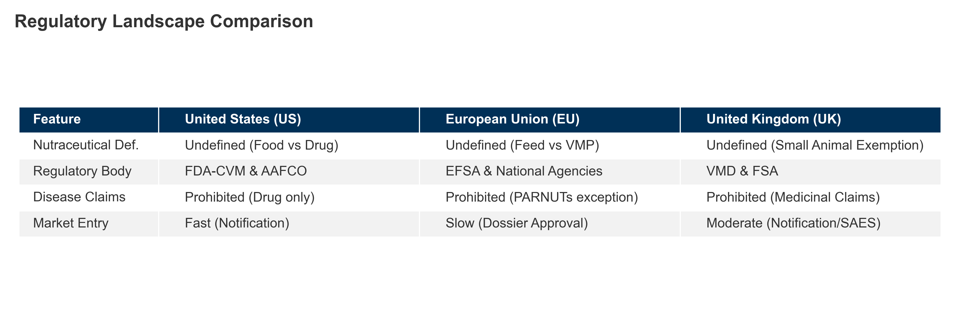 Source: FDA GFI #293, EU Reg 1831/2003*

**Regulatory Bans Are the Primary Catalyst for Volume Expansion.** History confirms that in the livestock sector, regulation is the “Stick” that compels adoption. Two major regulatory events have reshaped the competitive landscape, transforming nutraceuticals from discretionary additives into non-negotiable sanitary infrastructure (see Figure 2). The **Global AGP Bans** (EU 2006, US 2017, China 2020) stripped producers of their primary yield tool, creating an immediate, biological vacuum that only functional nutraceuticals (probiotics, organic acids) could fill. Similarly, the **EU Zinc Oxide Ban (2022)** forced swine producers to pivot to gut-health alternatives. These events prove that **Regulatory Beta** is the single most potent driver of volume: when a chemical tool is banned, biological alternatives do not just grow; they explode.

***Figure 2: Regulatory accelerators like AGP bans have historically driven volume adoption.*** *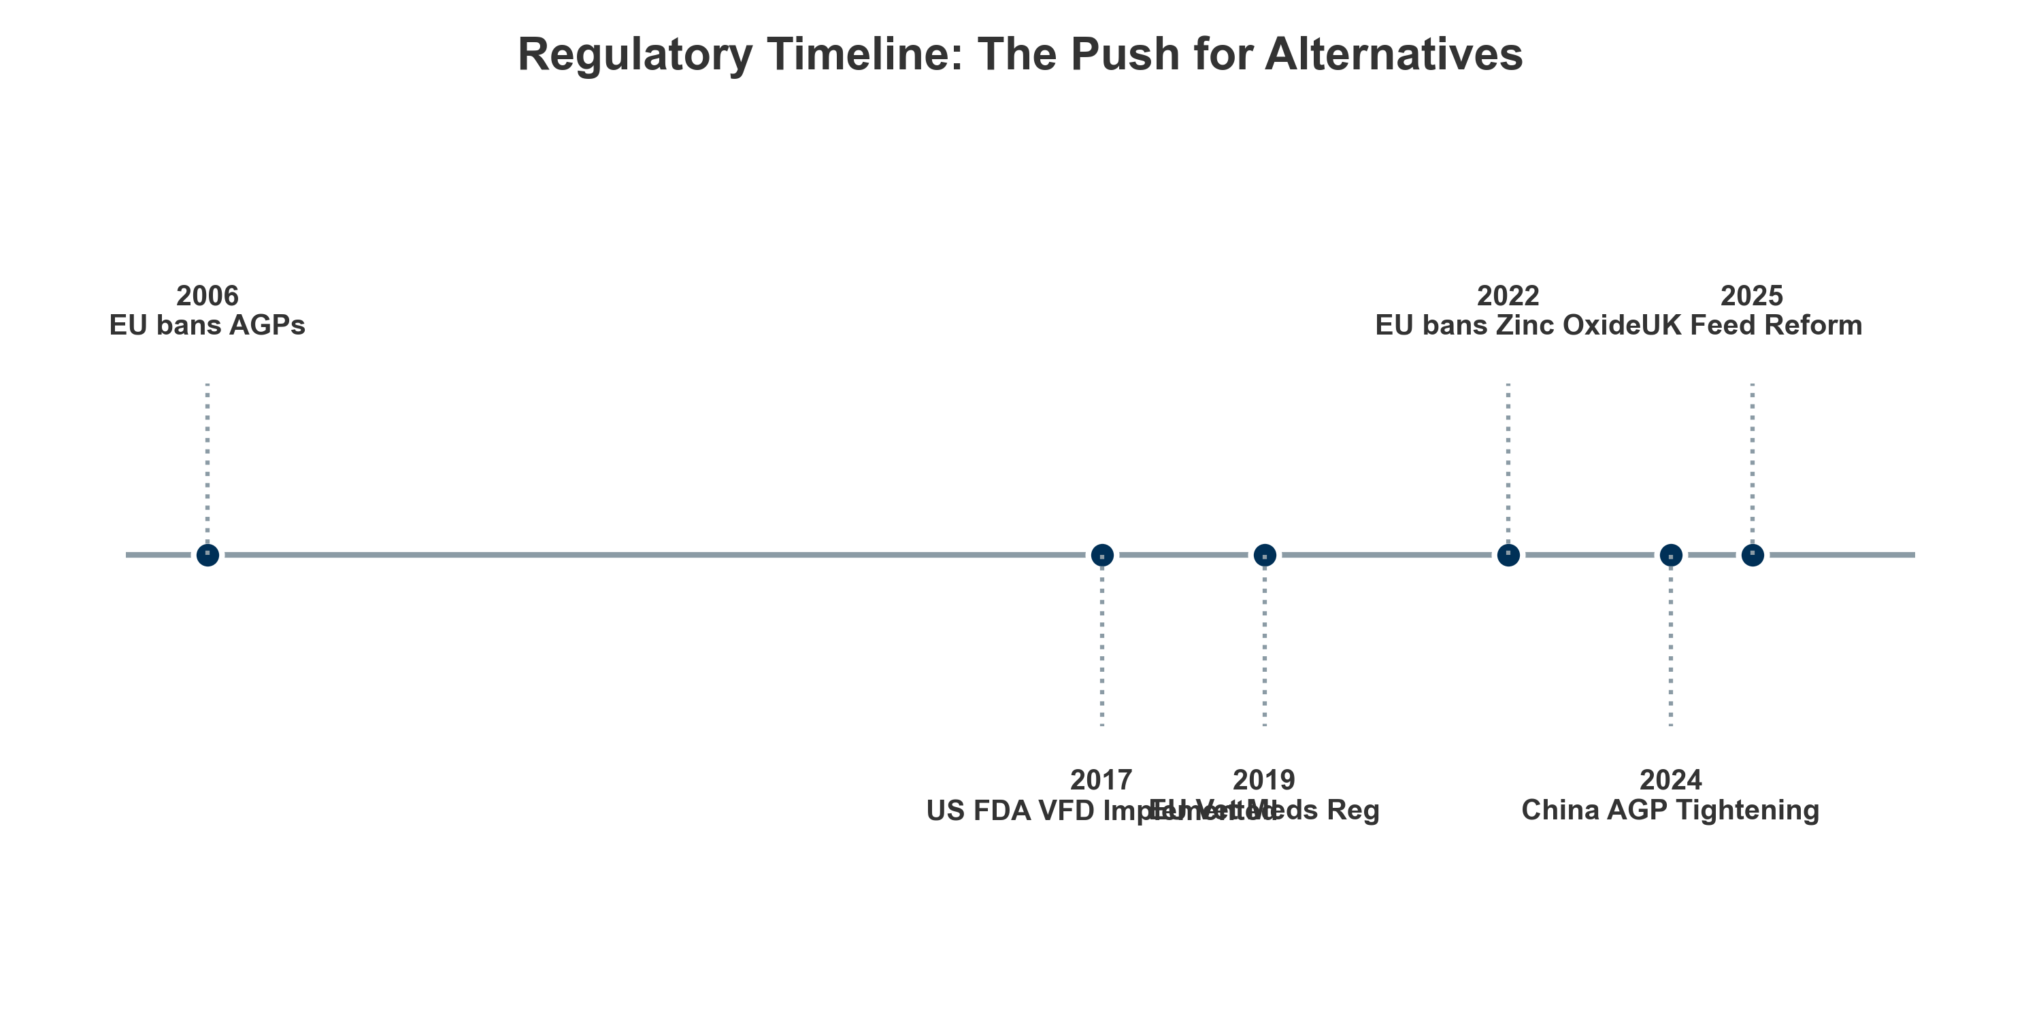 Source: Internal Analysis based on Regulatory Decrees*

**Regulatory Classification Dictates Unit Economics.** Investors must distinguish between legal classification and commercial utility, as the regulatory pathway determines pricing power (see Figure 3). Moving from a generic **“Feed Material”** (compliance-driven) to a **“Feed Additive”** (function-driven) or **“Veterinary Drug”** (therapy-driven) exponentially increases the strength of permissible claims. This “Claim Strength” is directly accretive to gross margins, as it allows companies to charge for *outcomes* rather than *inputs*. As illustrated in Table I.1 and reconciled in Figure 4, the **$13 billion investable universe** is strictly defined by those assets that have transcended the “Feed Material” commodity trap to capture the surplus value of functional claims.

***Figure 3: Regulatory pathways dictate unit economics and allowable claims.*** *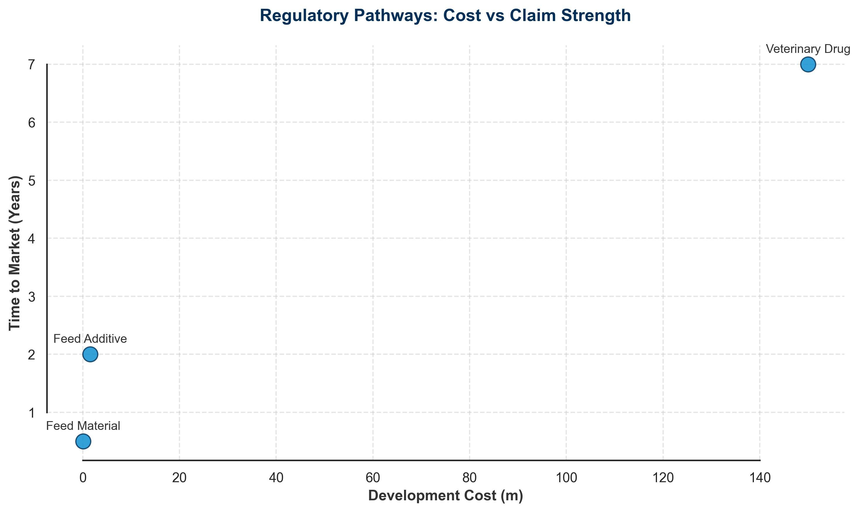 Source: Internal Regulatory Analysis*

**Table I.1: Global Regulatory Access Strategy** | **Region** | **Strategic Imperative** | **Key Regulation** | **The Grey Zone Strategy** | **Market Access Key** | |:— |:— |:— |:— |:— | | **USA** | **Safety First** | Binary: Food vs. Drug. | **FDA GFI #293** | Position as **“Supplement”** to avoid Drug classification. | **NASC Seal**: The de facto license to operate. | | **EU** | **Efficacy First** | Feed vs. VMP. | **Reg (EC) 1831/2003** | Leverage **“Zootechnical”** category for premium claims. | **EFSA Dossier**: High capital barrier to entry. | | **China** | **Compliance First** | **Strictly Regulated.** | **MoA Decree 20** | **“Pet Feed”** classification is the only viable route. | **MARA License**: Mandatory and rigorous. |

***Figure 4: Market reconciliation excludes commodities to define the investable high-value universe.*** *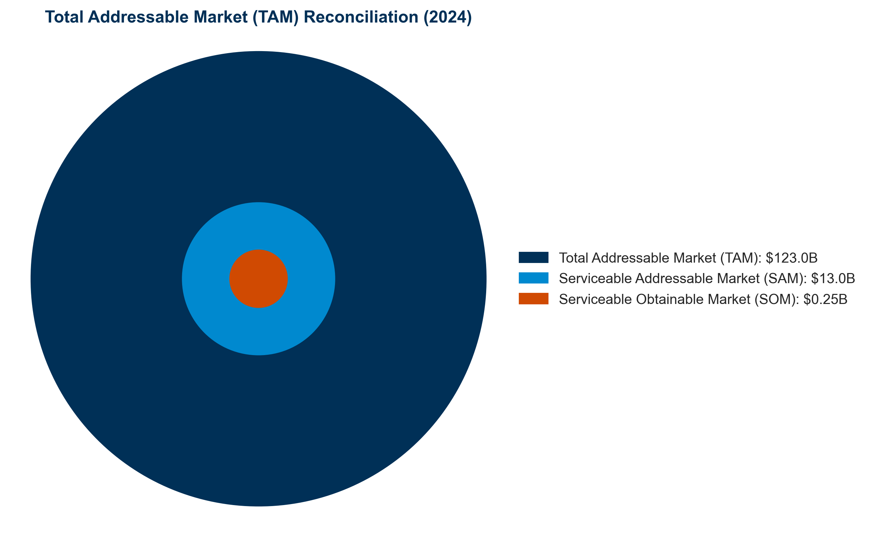 Source: Grand View Research (2024), Euromonitor (2024)*

## **I.2. Clinical Evidence Determines Pricing Power**

**Clinical Efficacy is the Only Defensible Moat Against Commoditization.** In a market saturated with generic “fairy dust,” our analysis confirms that **Clinical Validity** is the primary determinant of pricing power and gross margin expansion. We identify a direct, non-linear correlation between the **Level of Evidence (LoE)** and the commercial architecture a product can sustain (see Table I.2). While commodity players fight a race to the bottom, “Pharma-Nutra” players utilize **Level A (Therapeutic)** evidence—Randomized Controlled Trials (RCTs)—to unlock the Veterinary Channel. This is the **“Clinical Cliff”**: products without evidence fall into the commodity abyss, while those with evidence ascend to **Quasi-Drug status**, commanding price premiums of **+40% to +150%**.

**Table I.2: The Evidence-Premium Matrix** | Evidence Level | **Commercial Class** | **Sales Mechanics** | **Price Premium** | **Strategic Implication** | |:— |:— |:— |:— |:— | | **Level A (Therapeutic)** | **Quasi-Drug / Rx** | **Technical Sales (DVMs/PhDs).** High-Touch “Hunter” Model. | **+40% to +150%** | **Moat:** Clinical data creates a barrier to entry that generic competitors cannot breach. Examples: *Multimin 90, Dasuquin*. | | **Level B (Functional)** | **Premium OTC** | **Key Account Managers.** Edu-Marketing “Consultant” Model. | **+15% to +30%** | **Standard:** The minimum viable threshold for entering the veterinary channel. Examples: *OmniGen-AF, Zesty Paws*. | | **Level C (Generic)** | **Commodity** | **Distributors / Wholesalers.** Low-Touch “Order Taker” Model. | **0% (Baseline)** | **Risk:** High churn, price wars, and zero brand equity. |

**Evidence Directly Correlates with Customer Lifetime Value (CLV).** The price premium commanded by Level A assets is not arbitrary; it is a derivative of superior **Customer Lifetime Value** mechanics. Veterinary endorsement—secured only through robust clinical data—transforms a product from a “discretionary treat” to a “prescribed protocol,” reducing churn by **40–60%**. In chronic indications like Mastitis in dairy or Osteoarthritis in dogs, efficacy dictates the “stickiness” of the revenue. A *Level C* generic faces a 3-month churn cliff when the user sees no result; a *Level A* therapeutic sustains multi-year subscriptions because it delivers biologically measurable modifications. Thus, the cost of generating evidence ($100k–$150k per trial) is not an expense but a high-yield investment that amortizes Customer Acquisition Costs (CAC) over a significantly longer lifecycle.

**R&D Intensity Correlates Directly with EBITDA Margin Expansion.** We posit the existence of a “Pharma-Nutra Premium,” where R&D intensity acts as a leading indicator for future profitability. Financial data (2024/2025) confirms that companies investing **>5% of revenue in R&D** (e.g., Zoetis, Dechra) and publishing Clinical Data consistently command **EBITDA margins >20%**, whereas traditional feed players investing <1% languish in single digits (see Figure 6). This relationship holds true even in the “Emotional” pet sector, where **Brand Power** can occasionally substitute for R&D (e.g., Swedencare), but sustainable alpha is overwhelmingly generated by those creating—and proving—biological value.

***Figure 6: R&D intensity correlates directly with EBITDA margin expansion/premium.*** *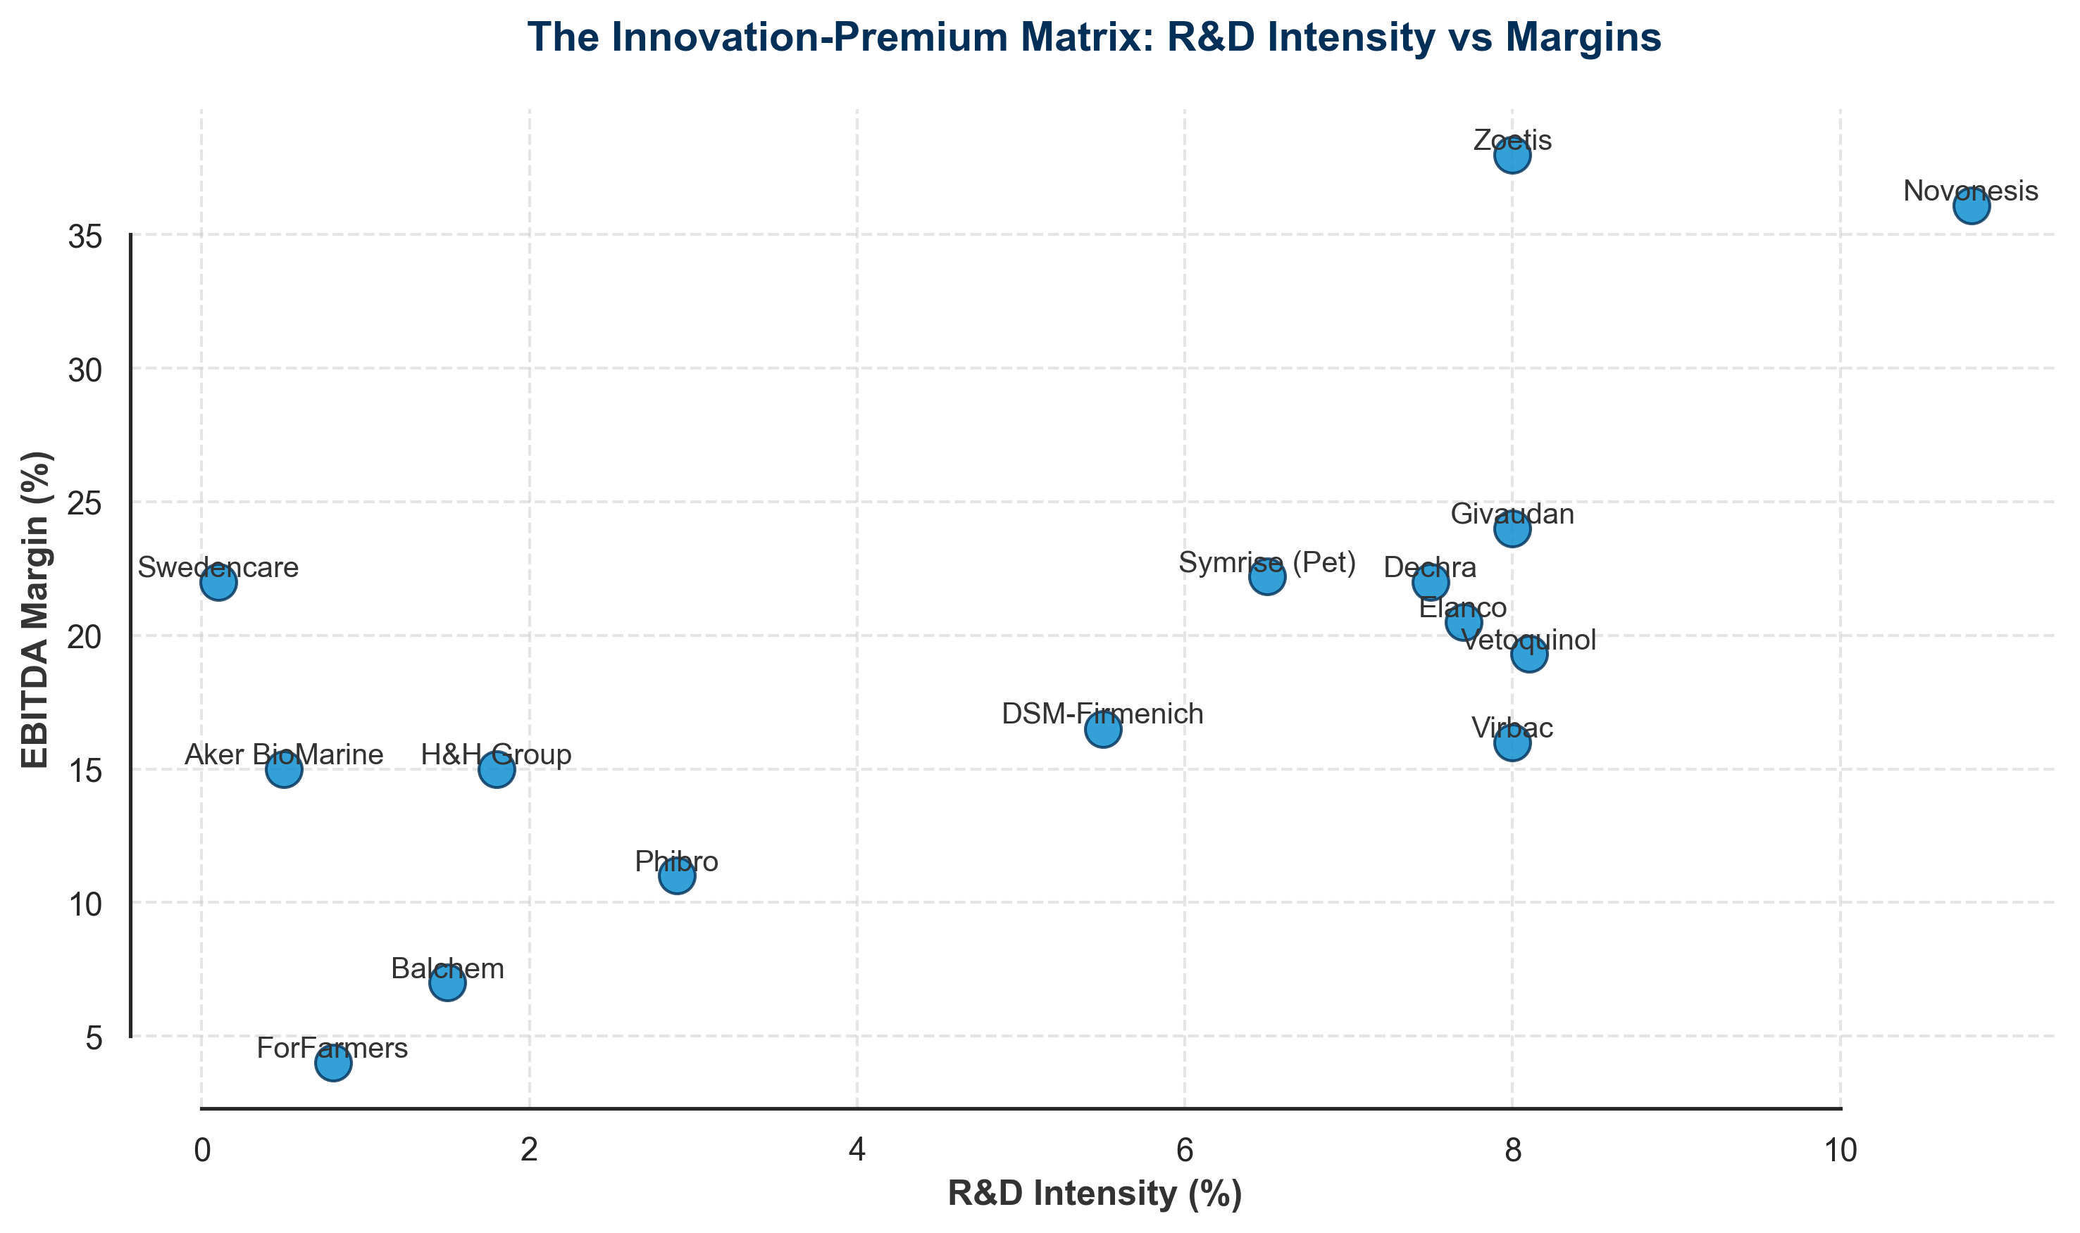 Source: Annual Reports 2024/2025; Internal Analysis (R&D Expense / Total Revenue)*

***Figure 7: Structural bifurcation splits the market into Emotional (Pet) and ROI (Livestock) economies.*** *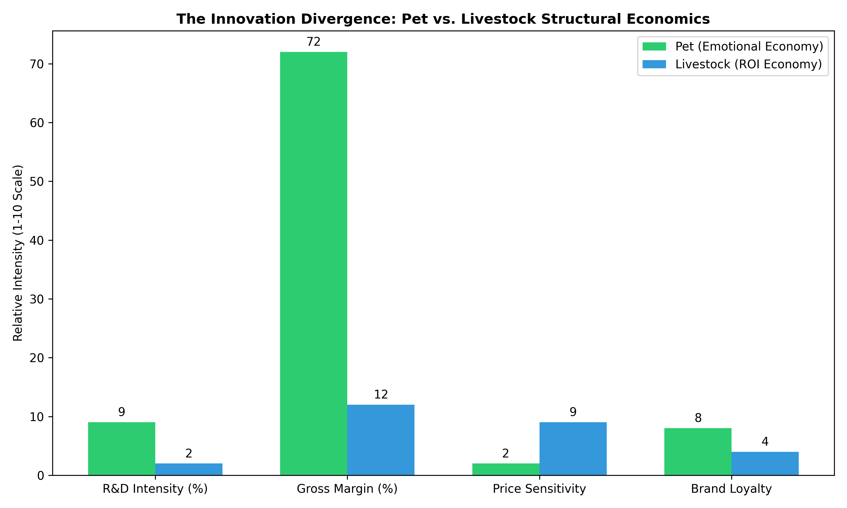 Source: Internal Analysis*

## **I.3. Functional Segmentation Pivots to Outcomes**

**Companion Animal Segments Shift from Care to “Cure”.** The pet sector is shedding its “treats” legacy and adopting a medicalized posture. **Mobility ($2.6B)**, the dominant category, is pivoting from volume-based Glucosamine to low-dose, immune-modulating actives like **UC-II Collagen** and **Omega-3s**, driven by the “Usage Paradox” where lower doses yield higher compliance (see Figure 8). Simultaneously, the **Cognitive Support ($1.35B)** and **Behavioral Wellness ($1.4B)** sectors are monetizing the “Silver Economy” and “Anxiety Economy” respectively. Innovations like **MCTs** for brain health (Figure 11) and **L-Theanine** for non-sedative anxiolysis (Figure 12) are proving that owners will pay a premium for products that manage the specific pathologies of aging and urbanization.

***Figure 8: Efficacy levels in Mobility define market positioning and pricing power.*** *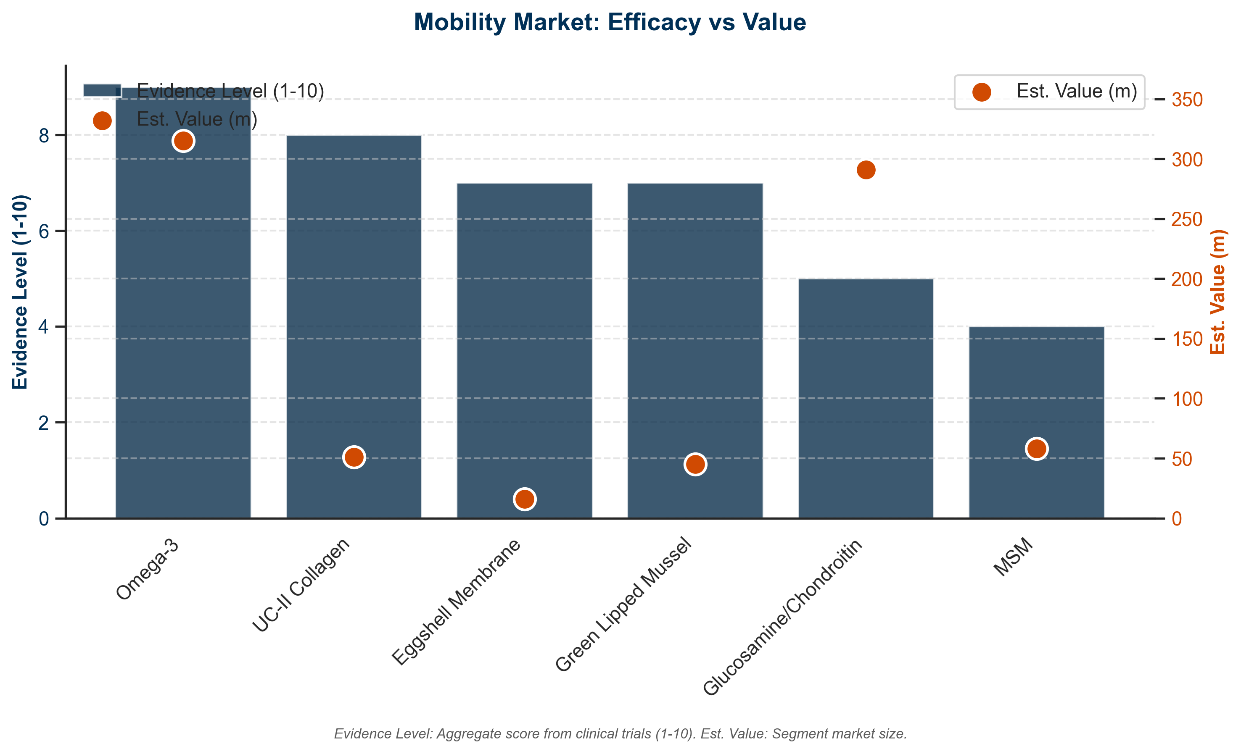 Source: Internal Efficacy Analysis*

***Figure 11: Cognitive support monetizes the Silver Economy via neuro-preservation.*** *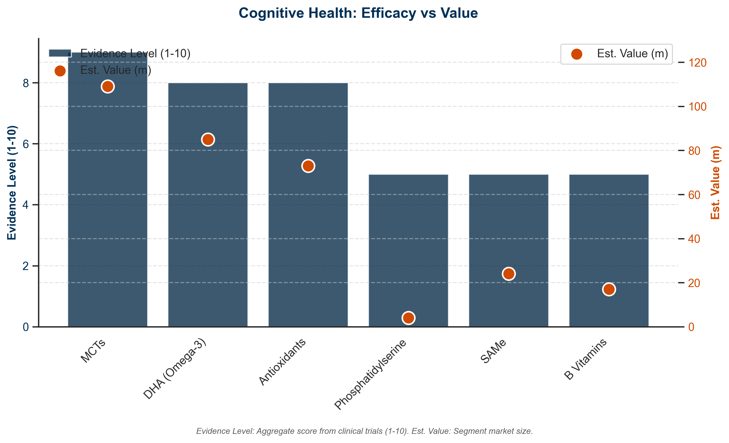 Source: Internal Efficacy Analysis*

***Figure 12: Non-sedative anxiolysis replaces pharmacological interventions in behavior management.*** *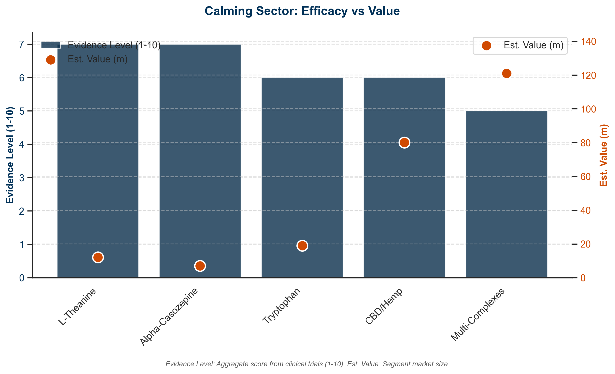 Source: Internal Efficacy Analysis*

**Livestock Segments Prioritize Biological Infrastructure.** In the livestock arena, nutraceuticals are replacing antibiotics as the new sanitary infrastructure. **Gut Health ($5.6B)** has evolved into a “Eubiosis” strategy, leveraging **Probiotics** and **Postbiotics** to create pathogen-resistant microbiomes (Figure 9). **Immunity ($2.67B)** and **Performance Additives ($7.1B)** focus on resilience and efficiency, using **Yeast Cultures** and **Enzymes** to optimize Feed Conversion Ratios (FCR) in an era of rising input costs (Figures 10 & 13). Here, the value proposition is purely financial: every dollar spent on additives must return >$3 in yield protection.

***Figure 9: Gut Health strategy shifts from generic digestion to precision microbiome modulation.*** *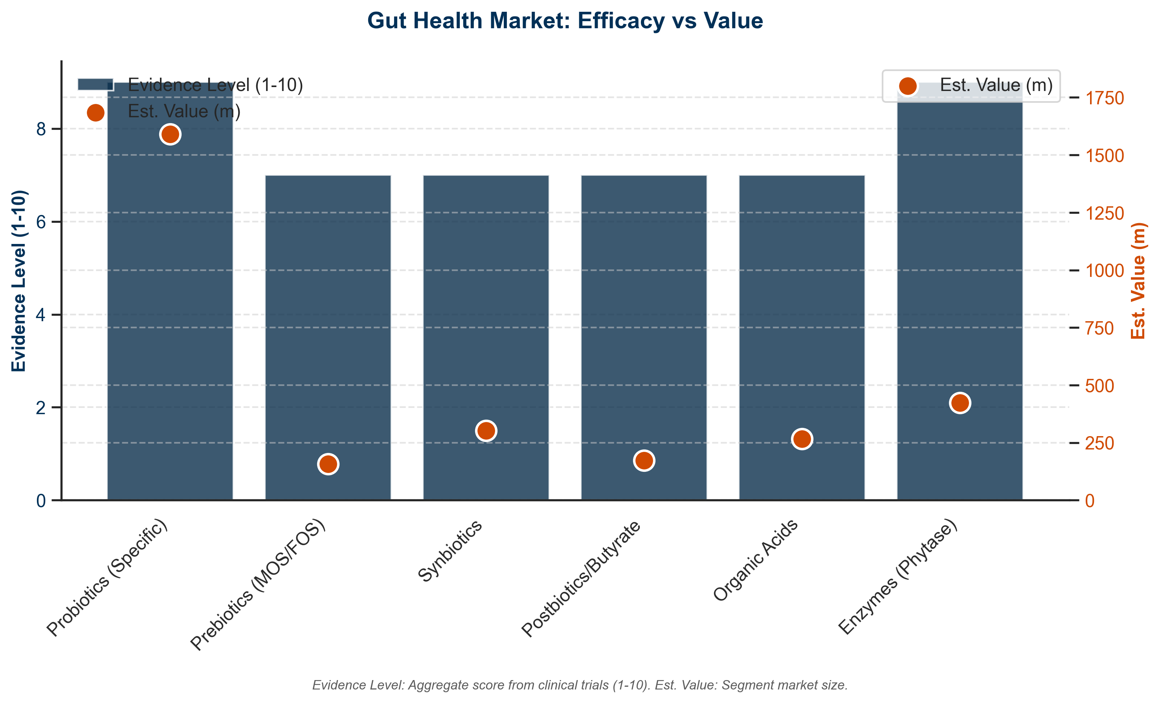 Source: Internal Efficacy Analysis*

***Figure 10: Immunity solutions build biological resilience for the post-antibiotic era.*** *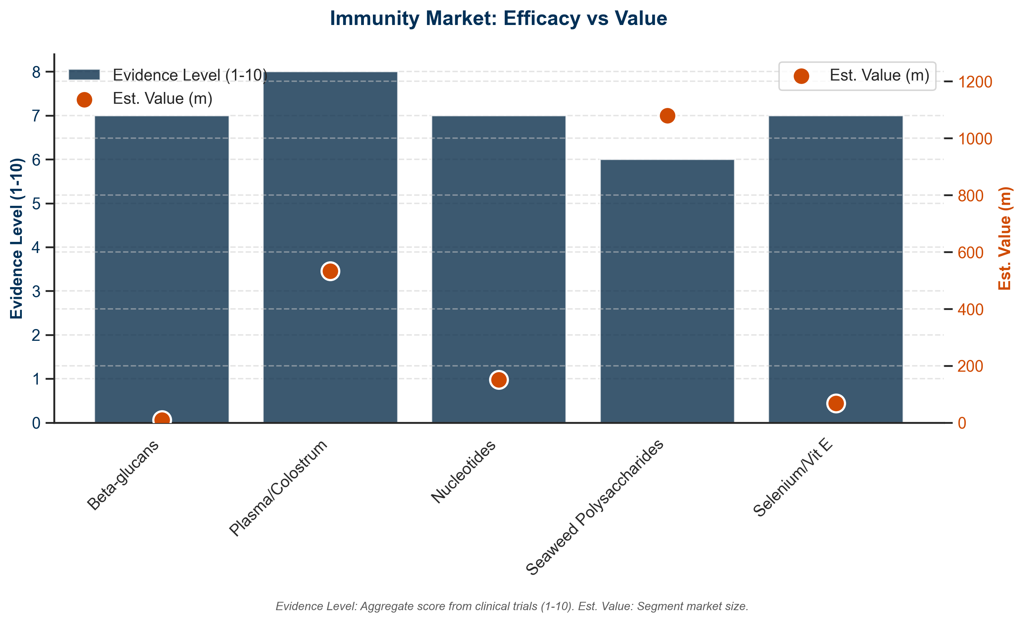 Source: Internal Efficacy Analysis*

***Figure 13: Enzymes and yeast cultures drive Feed Conversion Ratios (FCR) in livestock.*** *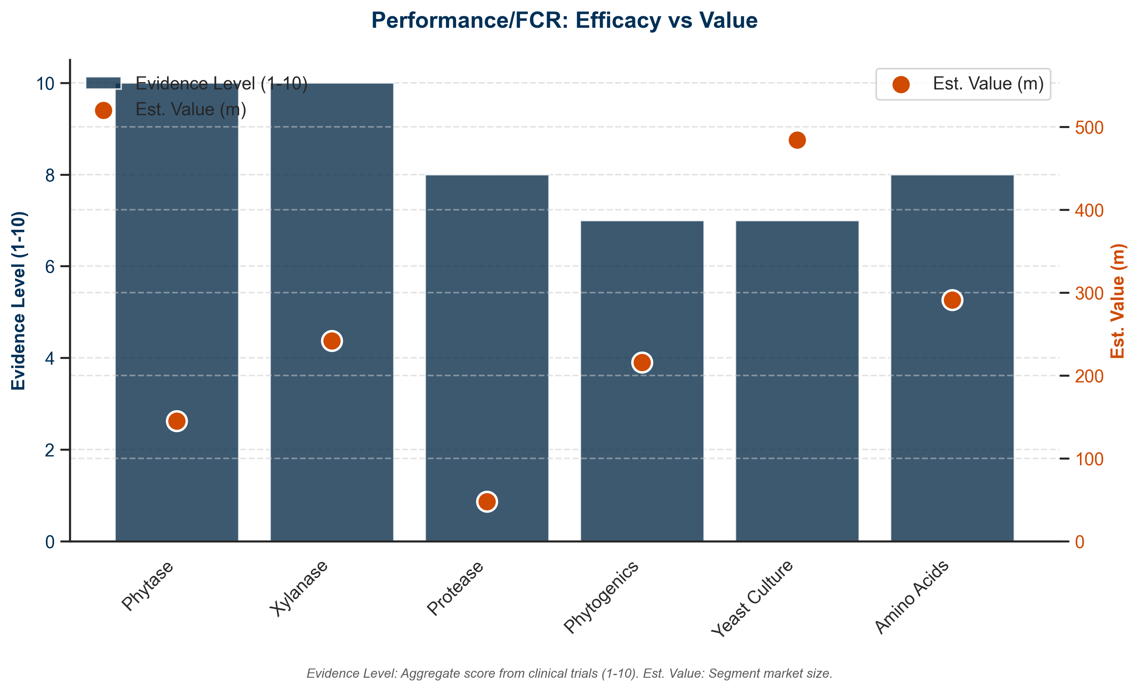 Source: Internal Efficacy Analysis*

**Emerging Technologies Define the Next Decade of Value.** The future value of the sector lies in **Nutrigenomics ($3.5B)** and **Sustainability ($3.35B)**. Nutrigenomics is creating a “Moat of Data” by validating ingredients through gene-expression profiles, effectively effectively turning natural extracts into verified technologies (Figure 16). Meanwhile, the Sustainability vector is monetizing environmental compliance, with **Methane Mitigation** (Figure 18) becoming a non-negotiable procurement specification for global dairy chains. Coupled with **Advanced Delivery Systems** (Figure 17) that guarantee bioavailability, these “Deep Tech” segments serve as the bridge between raw ingredients and reliable, claimable performance.

***Figure 16: Gene-expression data constructs a defensible moat of validation around ingredients.*** *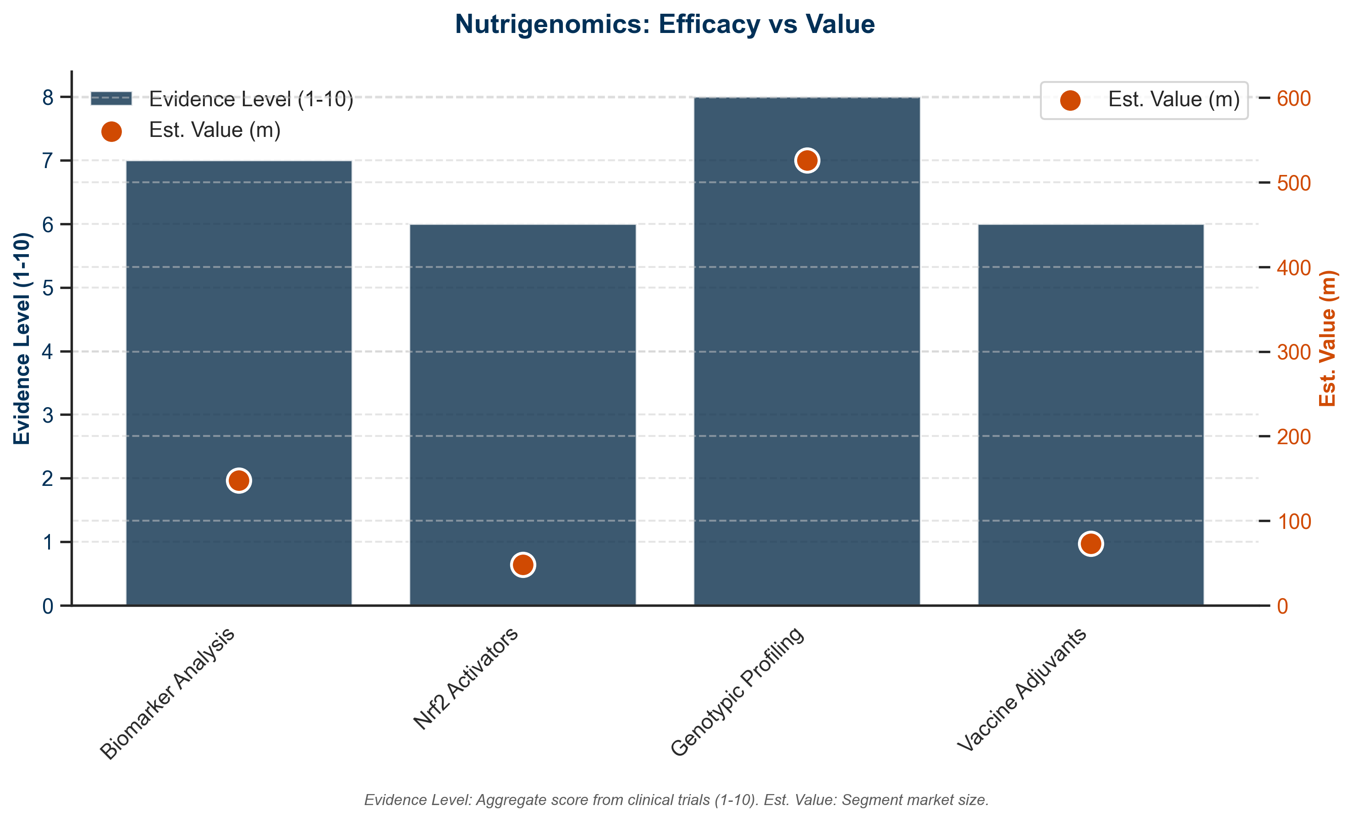 Source: Internal Efficacy Analysis*

***Figure 17: Advanced delivery formats ensure bioavailability and maximize compliance.*** *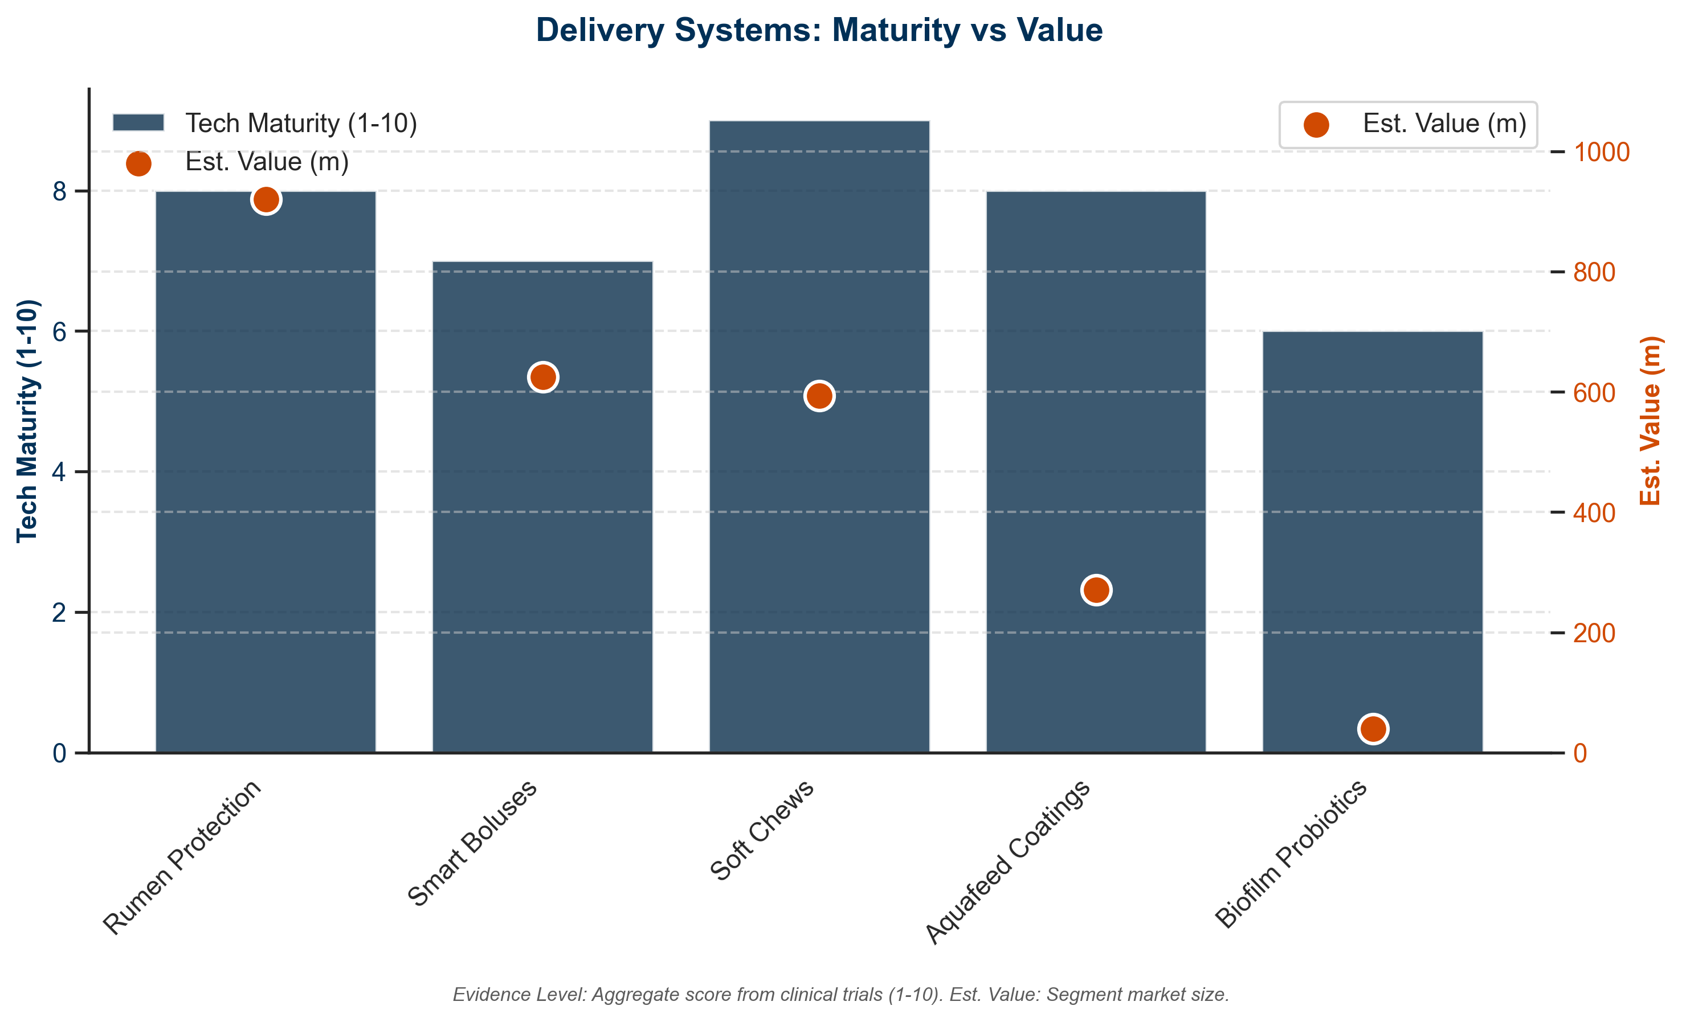 Source: Internal Technology Audit*

***Figure 18: Sustainability metrics like methane reduction are becoming non-negotiable procurement specs.*** *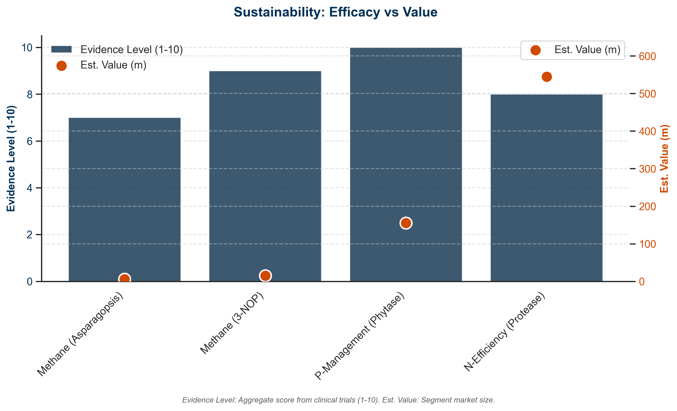 Source: Internal Efficacy Analysis*

**Conclusion: Precision Interventions Replace General Nutrition.** The transition is complete: the market has moved from “General Nutrition” to “Precision Intervention.” Winning categories are no longer defined by broad claims but by their ability to resolve specific biological problems—whether it be canine osteoarthritis or bovine methane emissions—with measurable, economically viable outcomes.

# **PART II: Strategic Bifurcation Drives Two-Speed Economics**

The global market has irreversibly split into two gears. Part II analyzes the “Two-Speed” economic reality where Global Demographics, Livestock Dynamics, and Buyer Psychology operate on divergent timelines. Investors must understand that “Growth” means something entirely different in a Tokyo cat café versus a Texan feedlot.

## **II.1. Demographic Divergence Decouples Growth**

**The Market Has Irreversibly Bifurcated into Value and Volume.** The global animal health market is undergoing a structural schism, creating a “Two-Speed” dynamic that invalidates aggregate market analysis. Investors must now model two distinct asset classes: the **Volume-Driven** livestock sector (correlated with GDP and population) and the **Value-Driven** pet economy (correlated with disposable income and household formation). Top-down analysis confirms that while the broader market is robust (~$123.8B), the alpha generation lies in this divergence. In developed markets, **Pet Nutraceuticals ($6B)** are driven by “Premiumization” and are forecast to double by 2030 (Figure 19), whereas **Livestock Additives ($7B)** are driven by the “Great Divergence”—a structural contraction in Western herds offset by relentless industrialization in the East.

***Figure 19: Developed markets prioritize ‘Value over Volume’ in pet ownership trends.*** *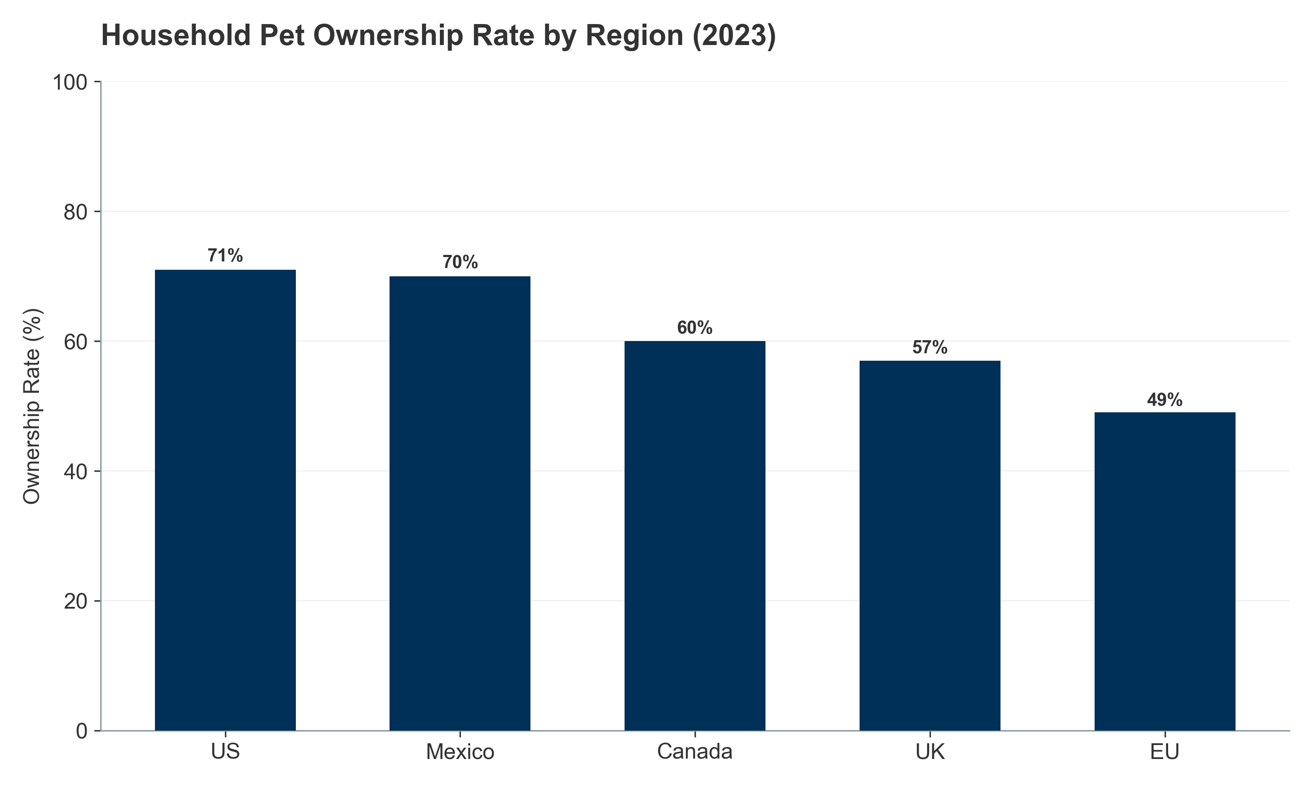 Source: FEDIAF (2024), APPA (2024)*

**Regional Nuances define the “Cat Continent” vs. the “Volume Engine”.** Europe differs fundamentally from the US; it is a **“Cat Continent”** (127M cats vs 104M dogs). The feline segment, growing at **+11%**, outpaces the dog segment due to urbanization and density constraints (Figures 20 & 21). This dictates a strategic pivot from canine-centric chews to feline-friendly liquids and transdermal gels to capture the **$1.9B EU opportunity**, particularly in pharmacy-led markets like France and Germany. Conversely, the US remains the “Valuation Anchor,” where the humanization thesis has fully matured, transforming the market from “Ownership” to “Parenting” across 94 million households.

***Figure 20: European demographics show a structural dominance of the feline segment.*** *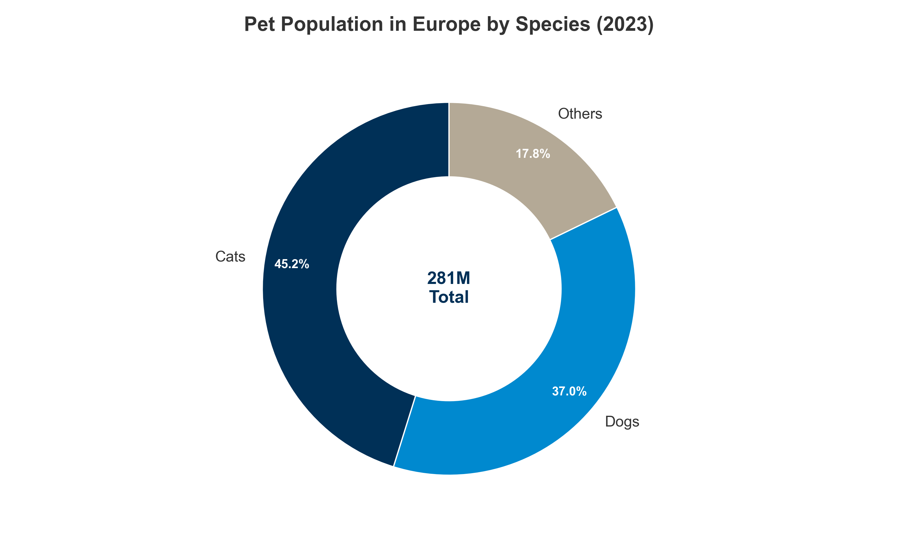 Source: FEDIAF Facts & Figures 2023*

***Figure 21: Feline segment growth outpaces canine due to urbanization constraints.*** *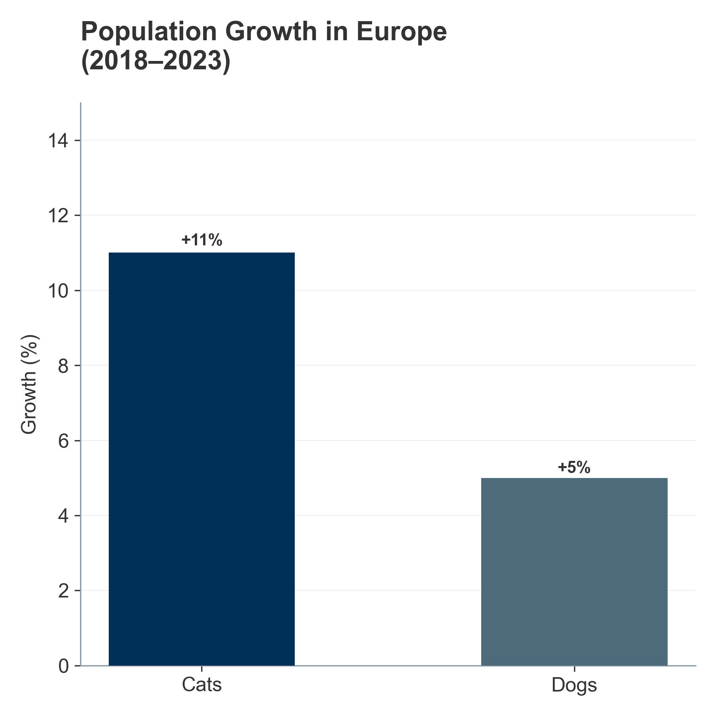 Source: FEDIAF (2024)*

**Asia-Pacific Emerges as the Volume Engine of the Next Decade.** While the West drives value, APAC drives volume. Urbanization and an emerging middle class are fueling a **12–15% CAGR** in India and China (Figure 22). Notably, China has flipped to a cat-majority market (71.5M cats) driven by the “996” work culture, which precludes dog ownership. This creates a highly specialized demand for stress and urinary health solutions in dense urban environments, signaling that future volume growth will be Asian, feline, and functional.

***Figure 22: APAC emerging as the primary volume engine for the next decade.*** *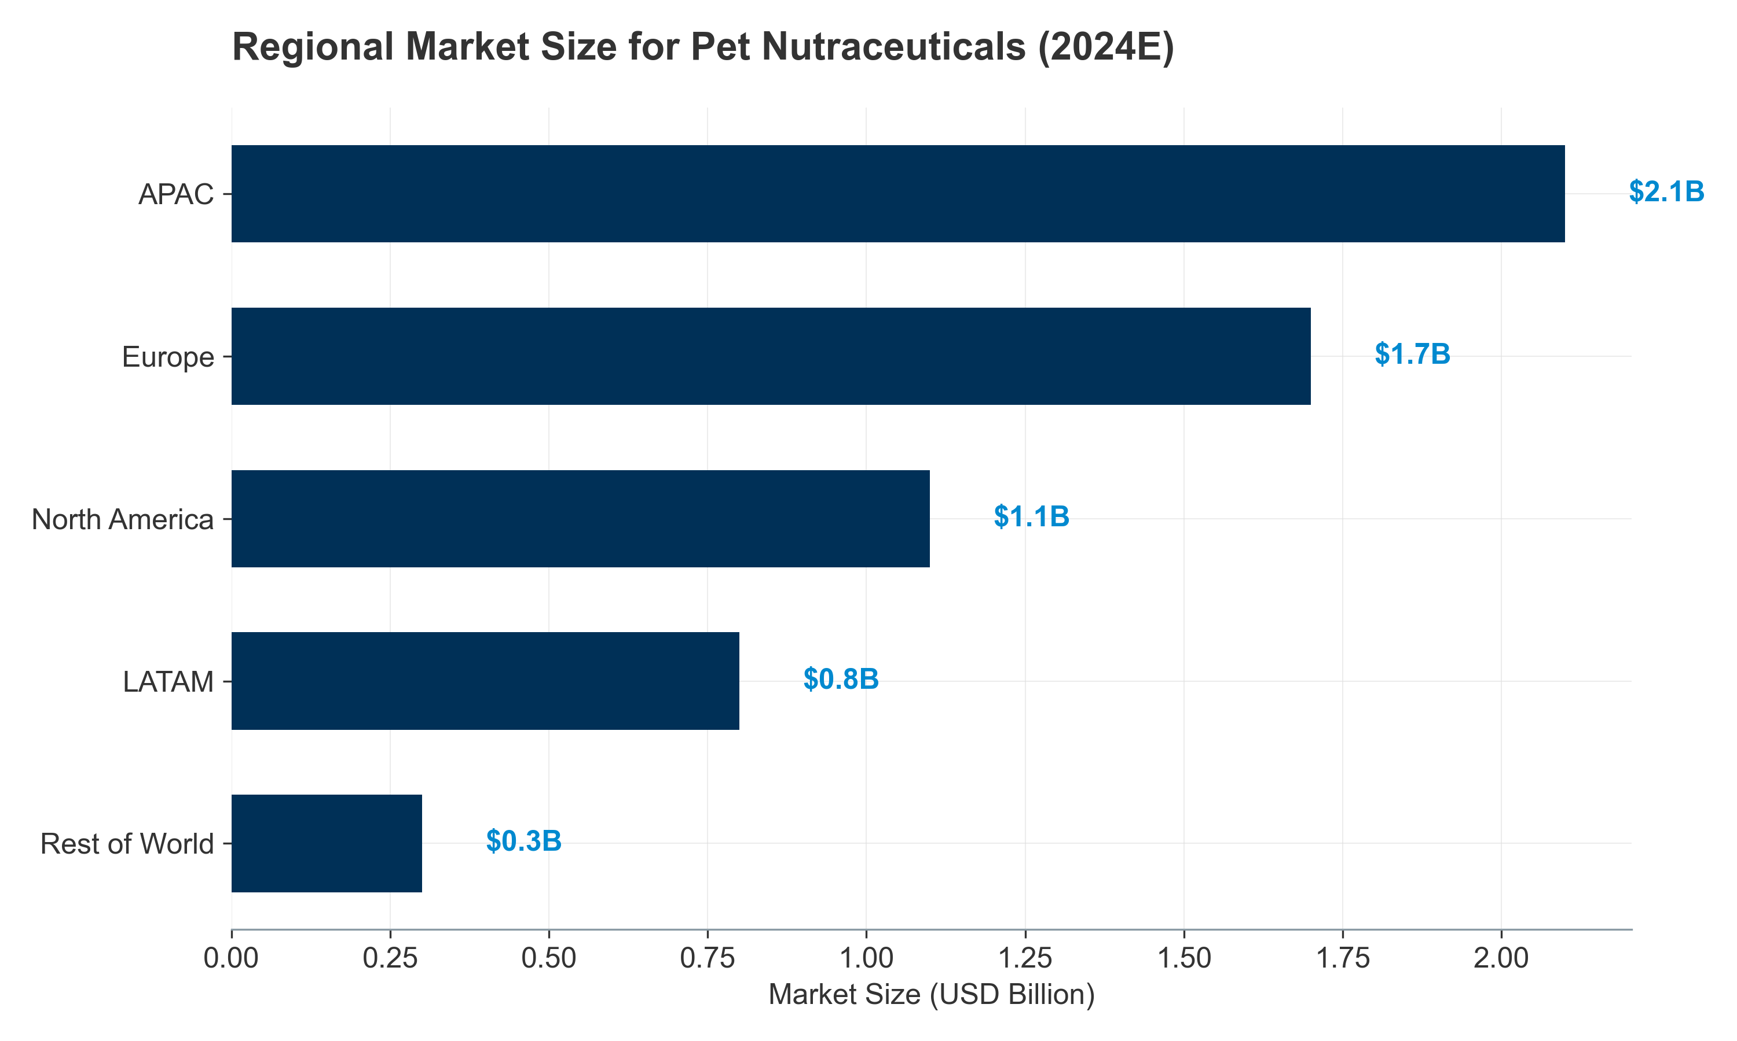 Source: Grand View Research (2024)*

## **II.2. Livestock Dynamics Prioritize Efficiency**

**The “Great Divergence” Favors Poultry and Aquaculture.** The livestock sector is characterized by a stark geographical and species split. **Poultry** has emerged as the global winner, dominating meat production (365M tonnes) and absorbing the majority of the **$6.8B feed additive** spend (Figures 23 & 24). It is a highly industrial, resilient sector where disease outbreaks (HPAI) engage a permanent demand for immune-modulating additives (Figure 25). Similarly, **Aquaculture ($250M)** represents the “Blue Transformation”—a permanent shift from wild capture to high-density farming that mandates probiotics as a biological life-support system (Figure 28).

***Figure 23: Global protein production shifts favor poultry and aquaculture over ruminants.*** *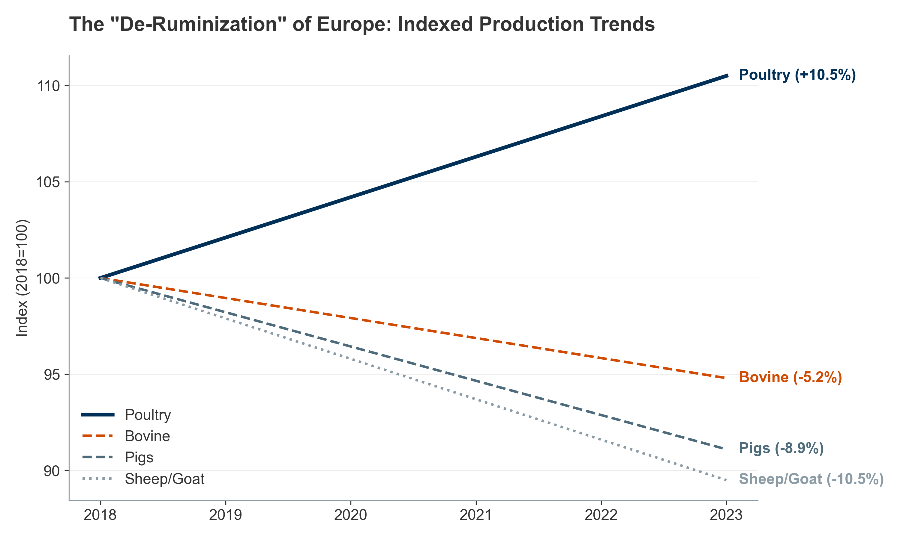 Source: FAO (2024)*

***Figure 24: Probiotics volume share reflects the dominance of poultry and swine sectors.*** *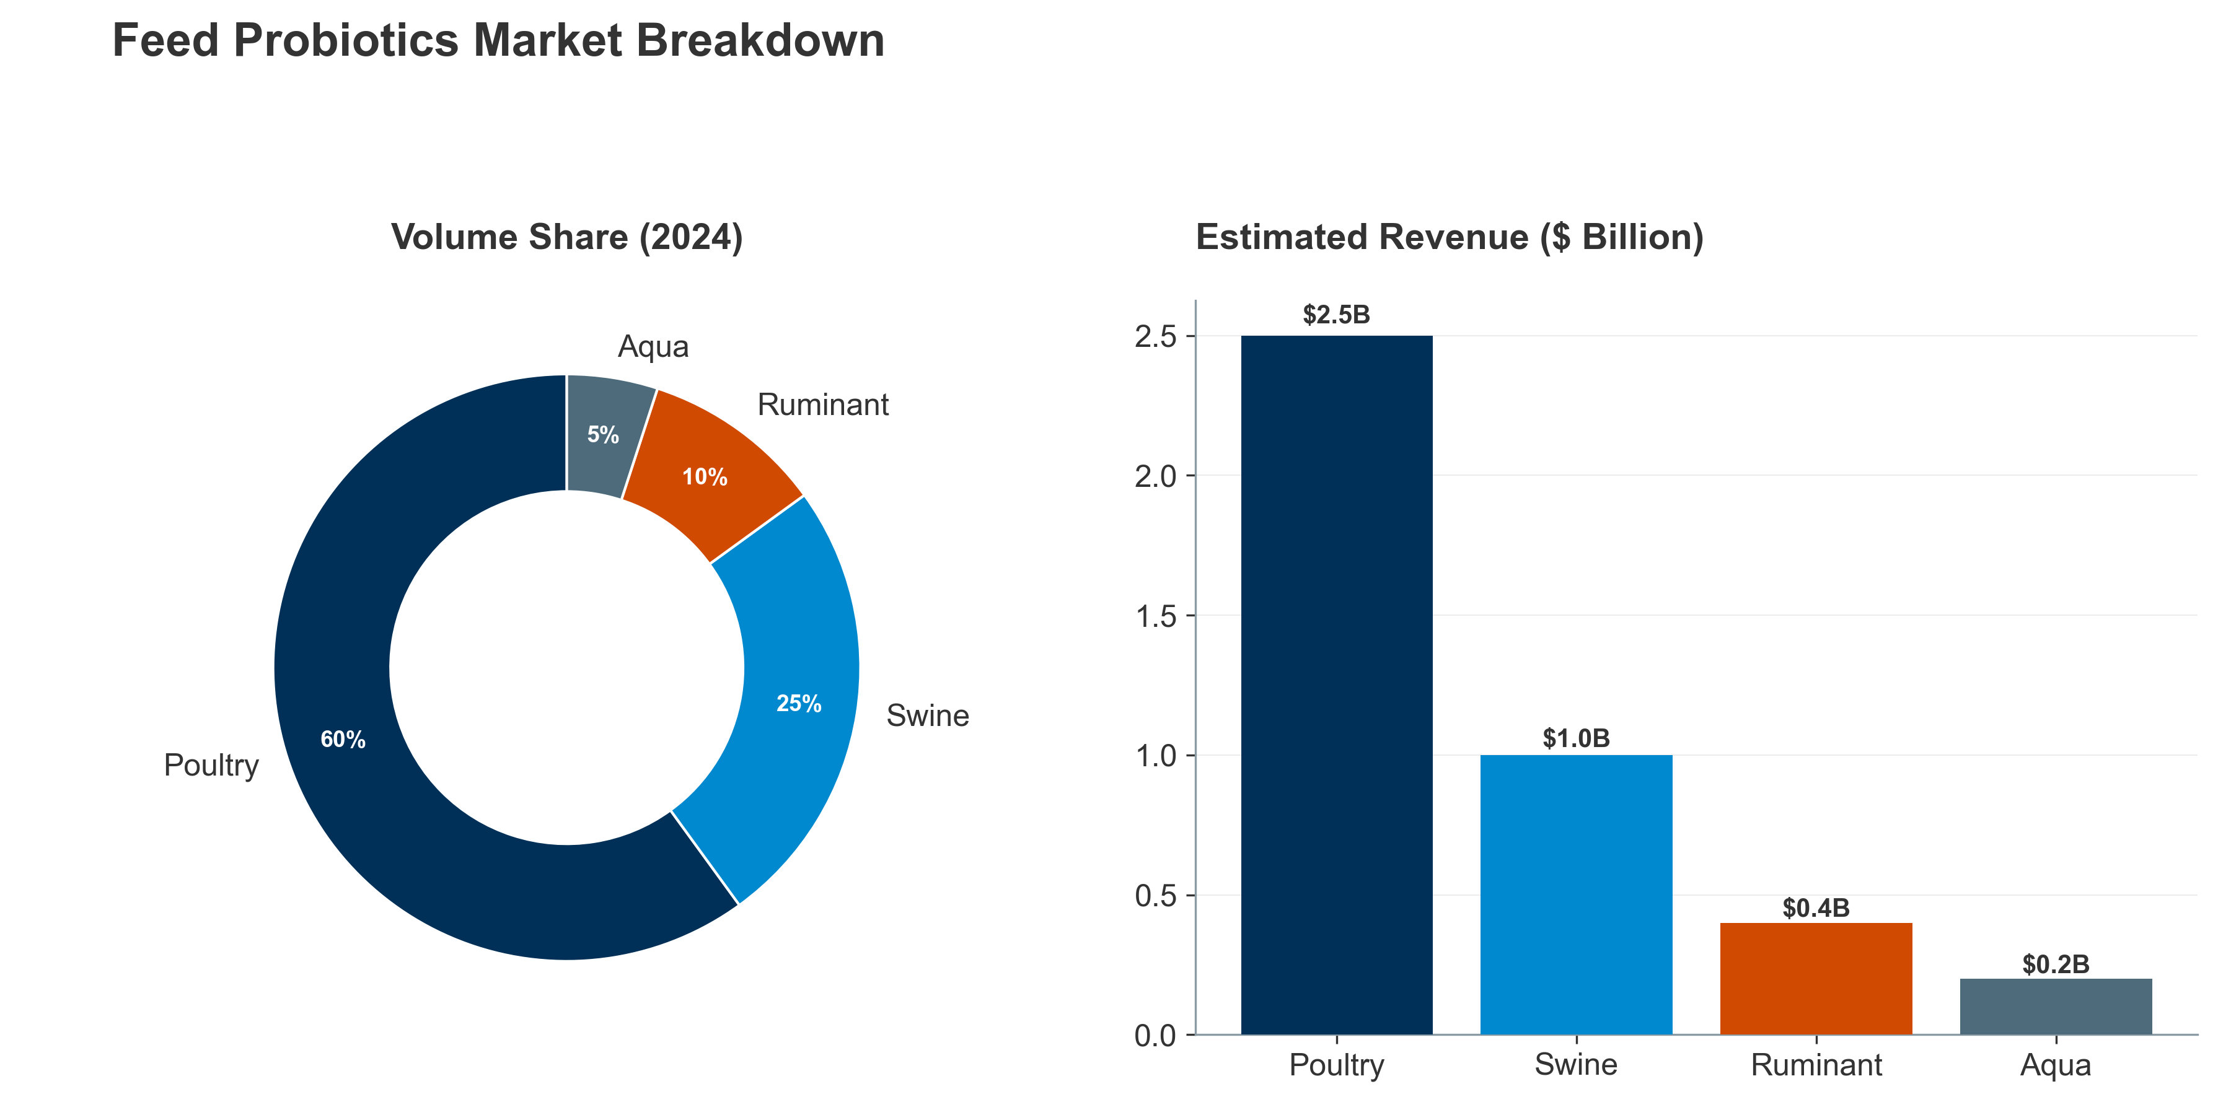 Source: MarketsandMarkets Animal Nutrition Report 2023*

***Figure 25: Disease outbreaks act as catalysts for immune-modulating additive demand.*** *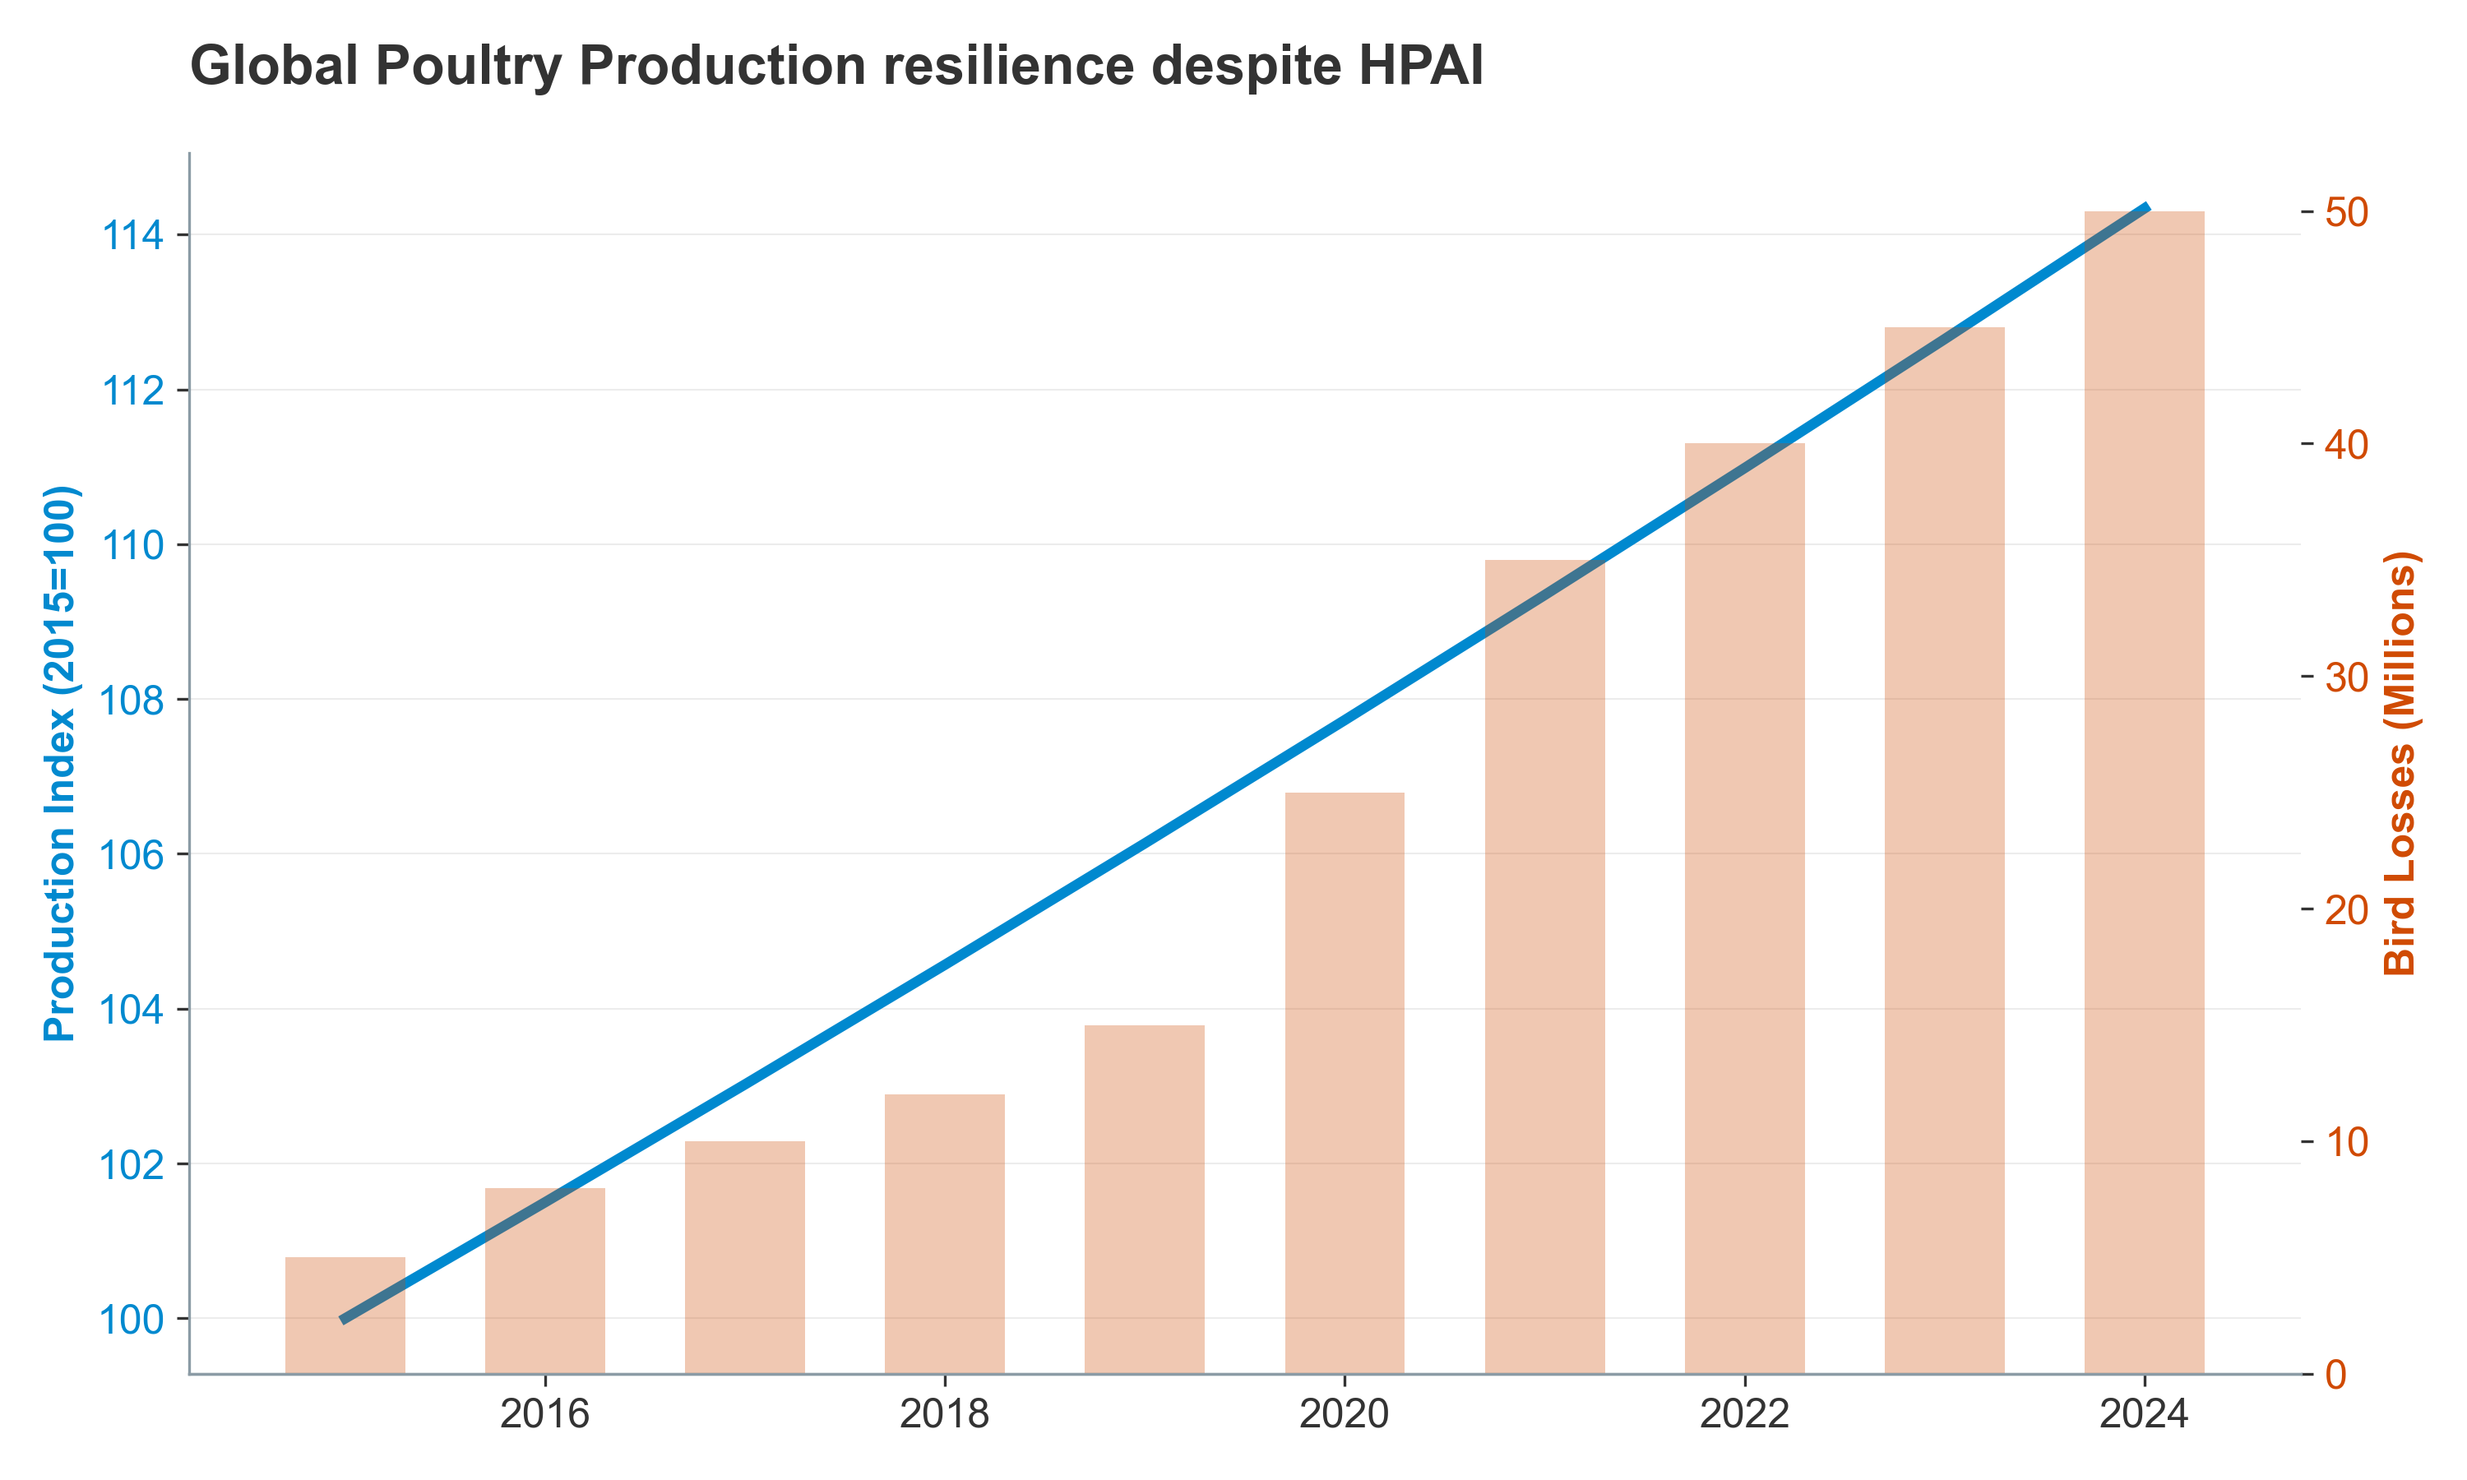 Source: WOAH WAHIS Situation Reports*

**Western Swine and Cattle Sectors Face Structural Contraction.** Conversely, the Western swine and cattle sectors are facing “De-Ruminization” and contraction driven by environmental policy (Figures 26 & 27). The Nitrogen Crisis in Europe is forcing a reduction in swine herds, prioritizing “Quality over Quantity” strategies where enzymes and gut health tools are essential to survive thin margins. In the cattle sector, historic liquidation shifts the thesis from “Masking” efficiency to “Maximizing” per-head value; shrinking herds mean that every remaining animal becomes a high-value asset justifying expensive inputs.

***Figure 26: Regulatory pressures drive structural contraction in Western swine herds.*** *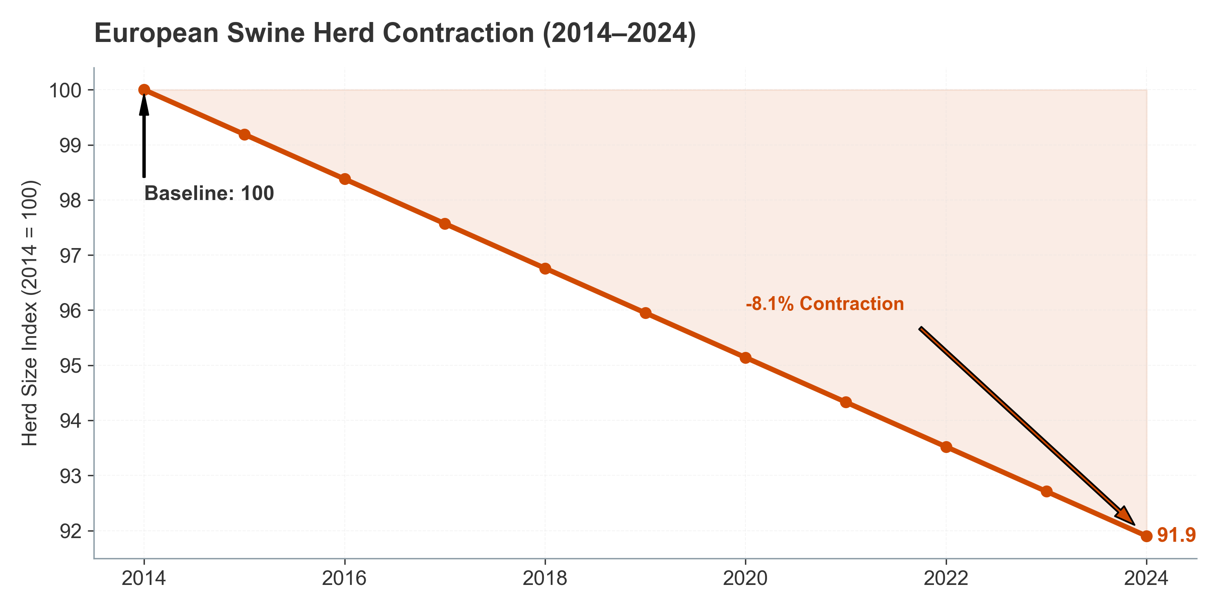 Source: Eurostat Livestock Statistics 2024*

***Figure 27: Western de-ruminization shifts value from herd size to efficiency-per-head.*** *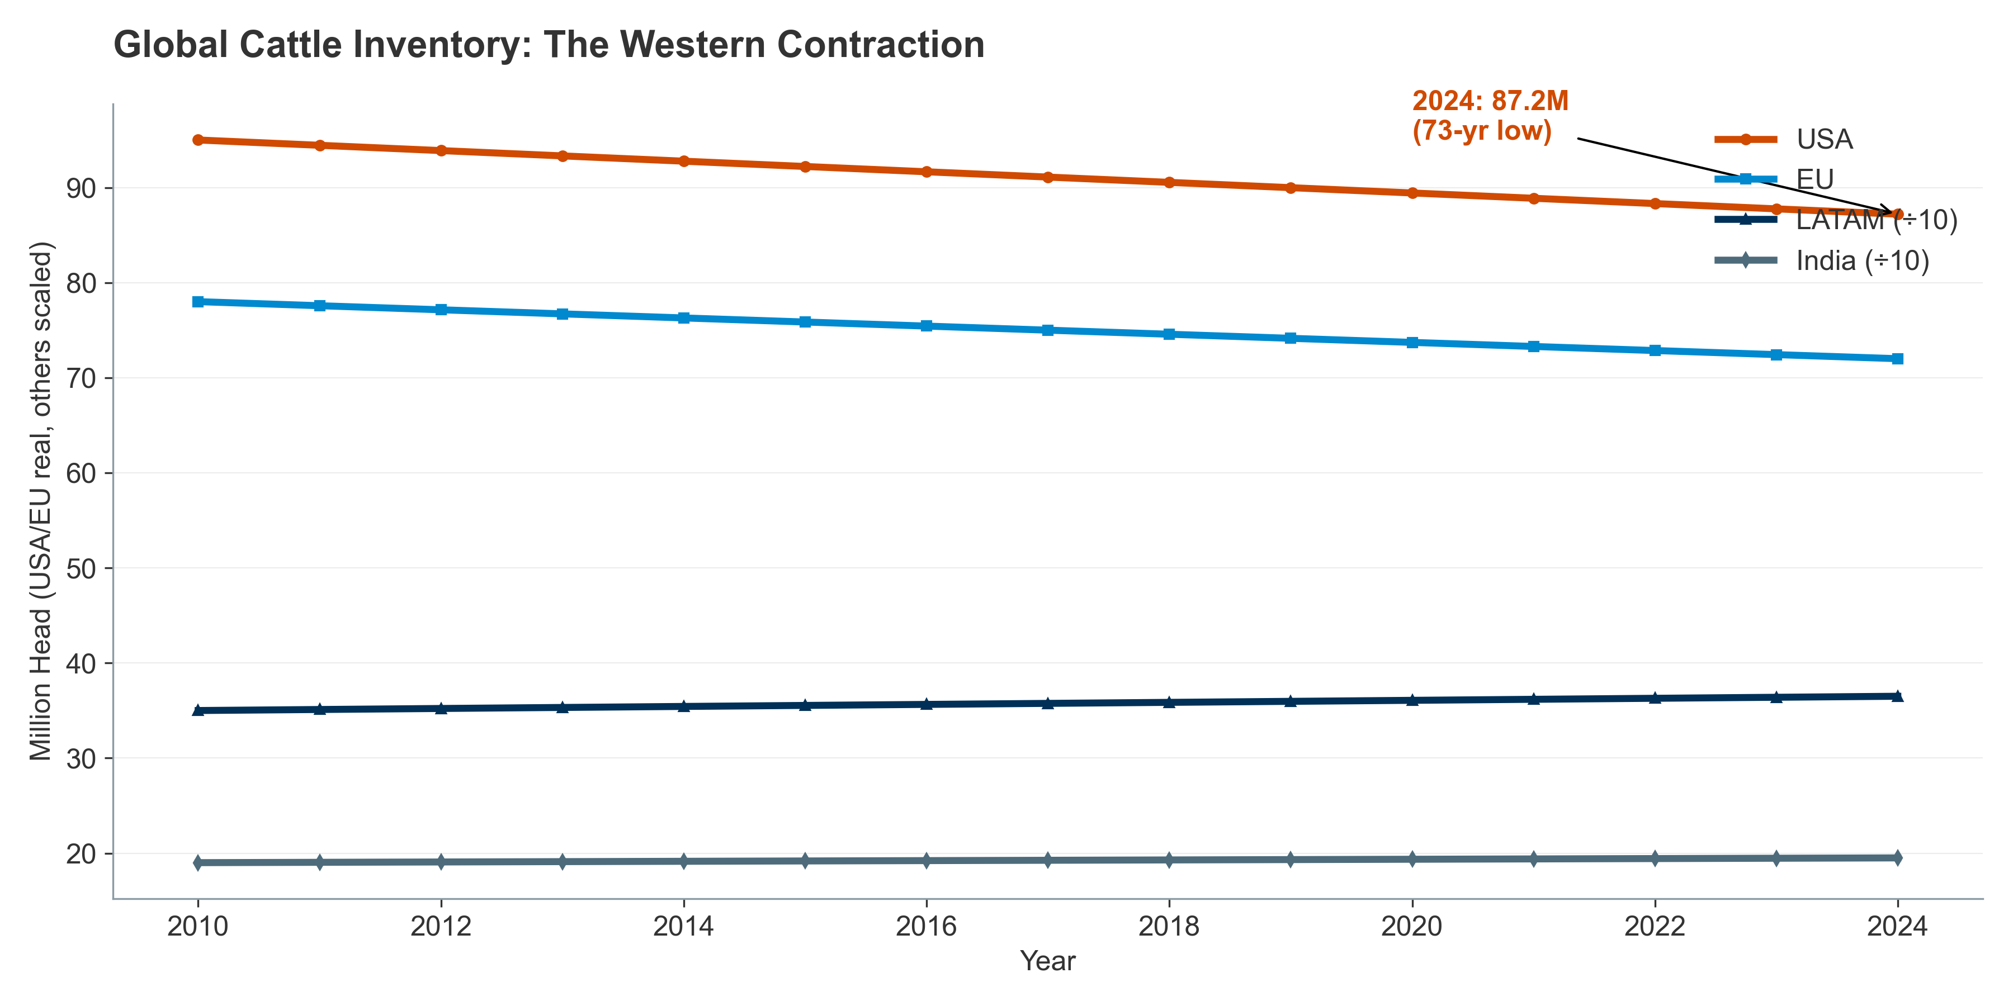 Source: Eurostat (2024), USDA (2024)*

***Figure 28: The ‘Blue Transformation’ drives industrialization and functional additive needs in aqua.*** *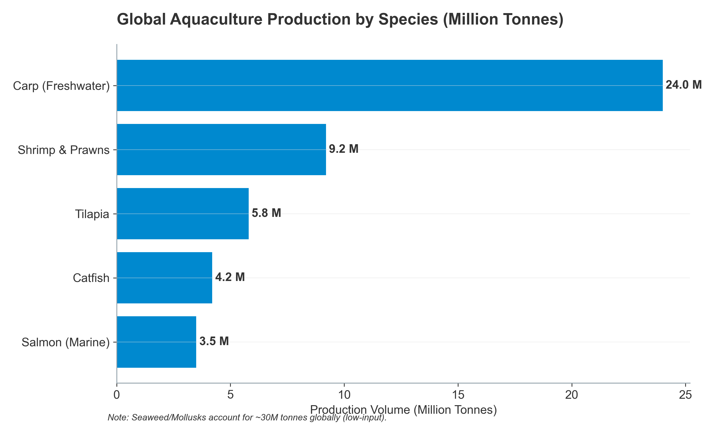 Source: FAO SOFIA 2024*

**Methane Mitigation Becomes a “License to Operate”.** The most profound shift in livestock dynamics is the pivot to **Methane Mitigation**. For the dairy and beef sectors, reducing emissions is no longer an optional “green” claim but a procurement mandate from global giants like Danone and Nestlé. This creates a new, non-discretionary market layer for technologies like **3-NOP** and **Bromoform**, which transform sustainability from a PR metric into a fundamental condition for market access.

## **II.3. Psychology of Spend Dictates Margins**

**Buyer Psychology is Driven by “Fear of Loss”.** Understanding the *why* of purchasing reveals that margin potential is psychological, not just functional. Analysis shows that **“Fear of Loss” (50%)** outweighs “Aspiration” (30%) in pet owner motivation (Figure 29). Owners pay premiums for preventive health to avoid the regret of premature aging, making the **Senior/Geriatric ($1.35B)** category the most price-inelastic. In livestock, the equivalent driver is **“Risk Mitigation”**; while producers operate on a strict ROI, they exhibit inelasticity for “Biological Insurance” (Toxin Binders) that prevents catastrophic herd loss.

***Figure 29: Purchasing psychology is driven more by the fear of loss than aspirational health.*** *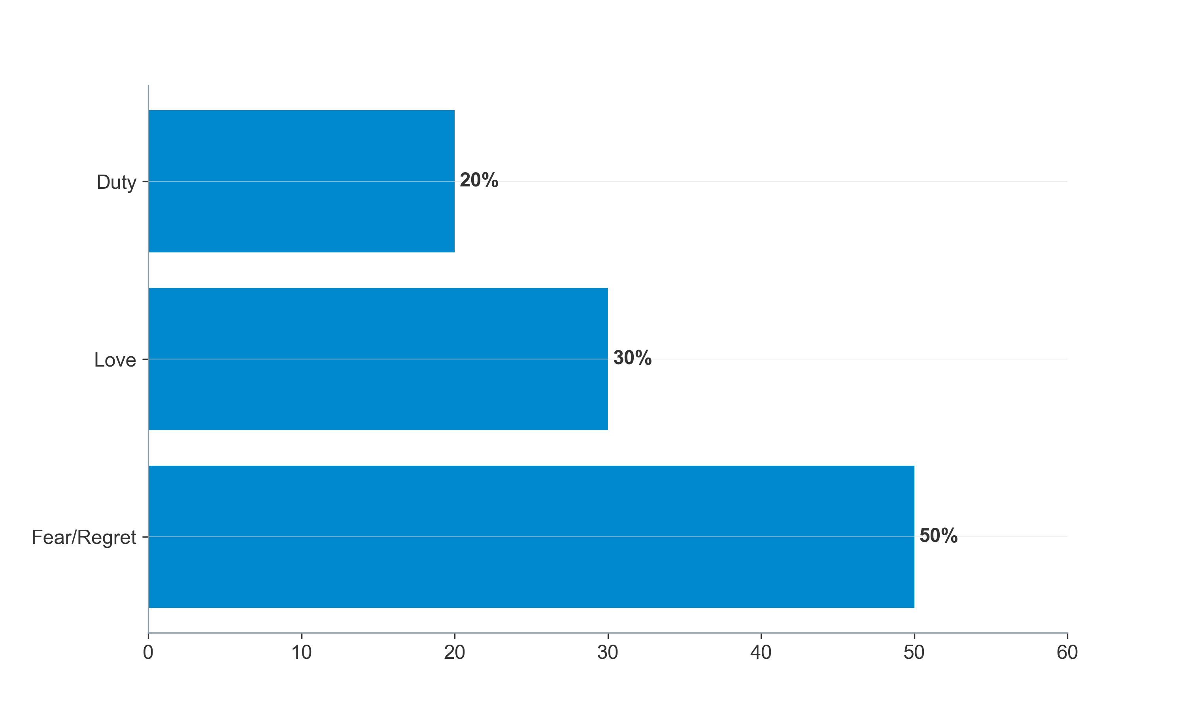 Source: Nicotra et al. (2025)*

**Palatability and Format Are Proxies for Efficacy.** The best active ingredient is worthless if the animal refuses to eat it. **Palatability** and **Format** dictate compliance, which in turn drives the perceived efficacy (Figure 30). In the companion market, the shift from pills to **Soft Chews ($593M)** and functional treats proves that the delivery system is as valuable as the payload. Brands that master palatability—making the “medicine” a “treat”—secure higher compliance rates and, by extension, higher repurchase rates.

***Figure 30: Palatability and format dictate compliance, which is a key efficacy driver.*** *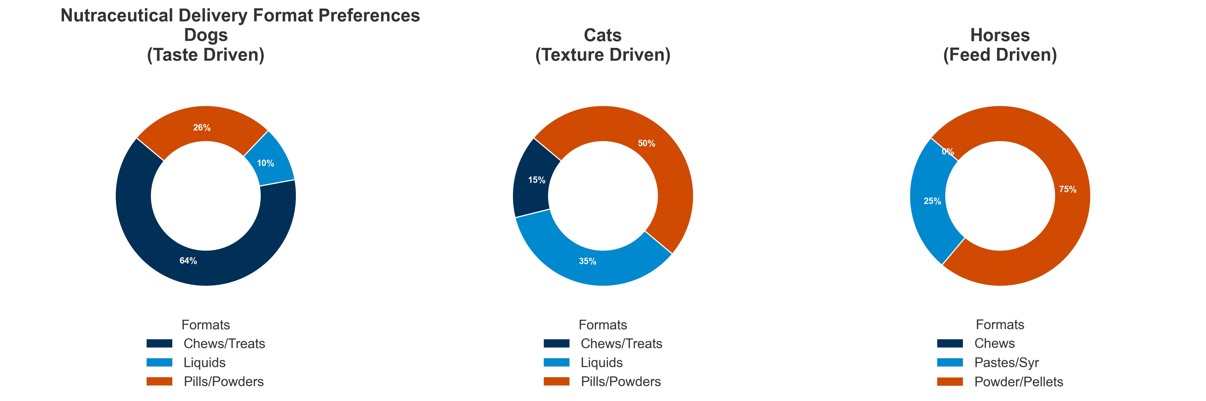 Source: Internal Format Analysis based on NBJ Data*

**Premiumization and Lifecycle Extensions Expand the Wallet.** The “Preventive Wallet” has expanded significantly, with nutraceuticals surpassing toys and accessories for high-spending owners (Figures 31 & 32). This is further amplified by the **“Premiumization Ladder”**—evident in mobility’s shift from generic Glucosamine to IP-backed Collagen (Figure 33)—and the emergence of the **“Pre-Senior”** category (Figure 34). By initiating wellness protocols at age 5 rather than age 8, brands actively double the Customer Lifetime Value (CLV), proving that the most effective way to grow the market is to lengthen the usage window.

***Figure 31: High-spending households drive the majority of revenue in the pet wellness category.*** *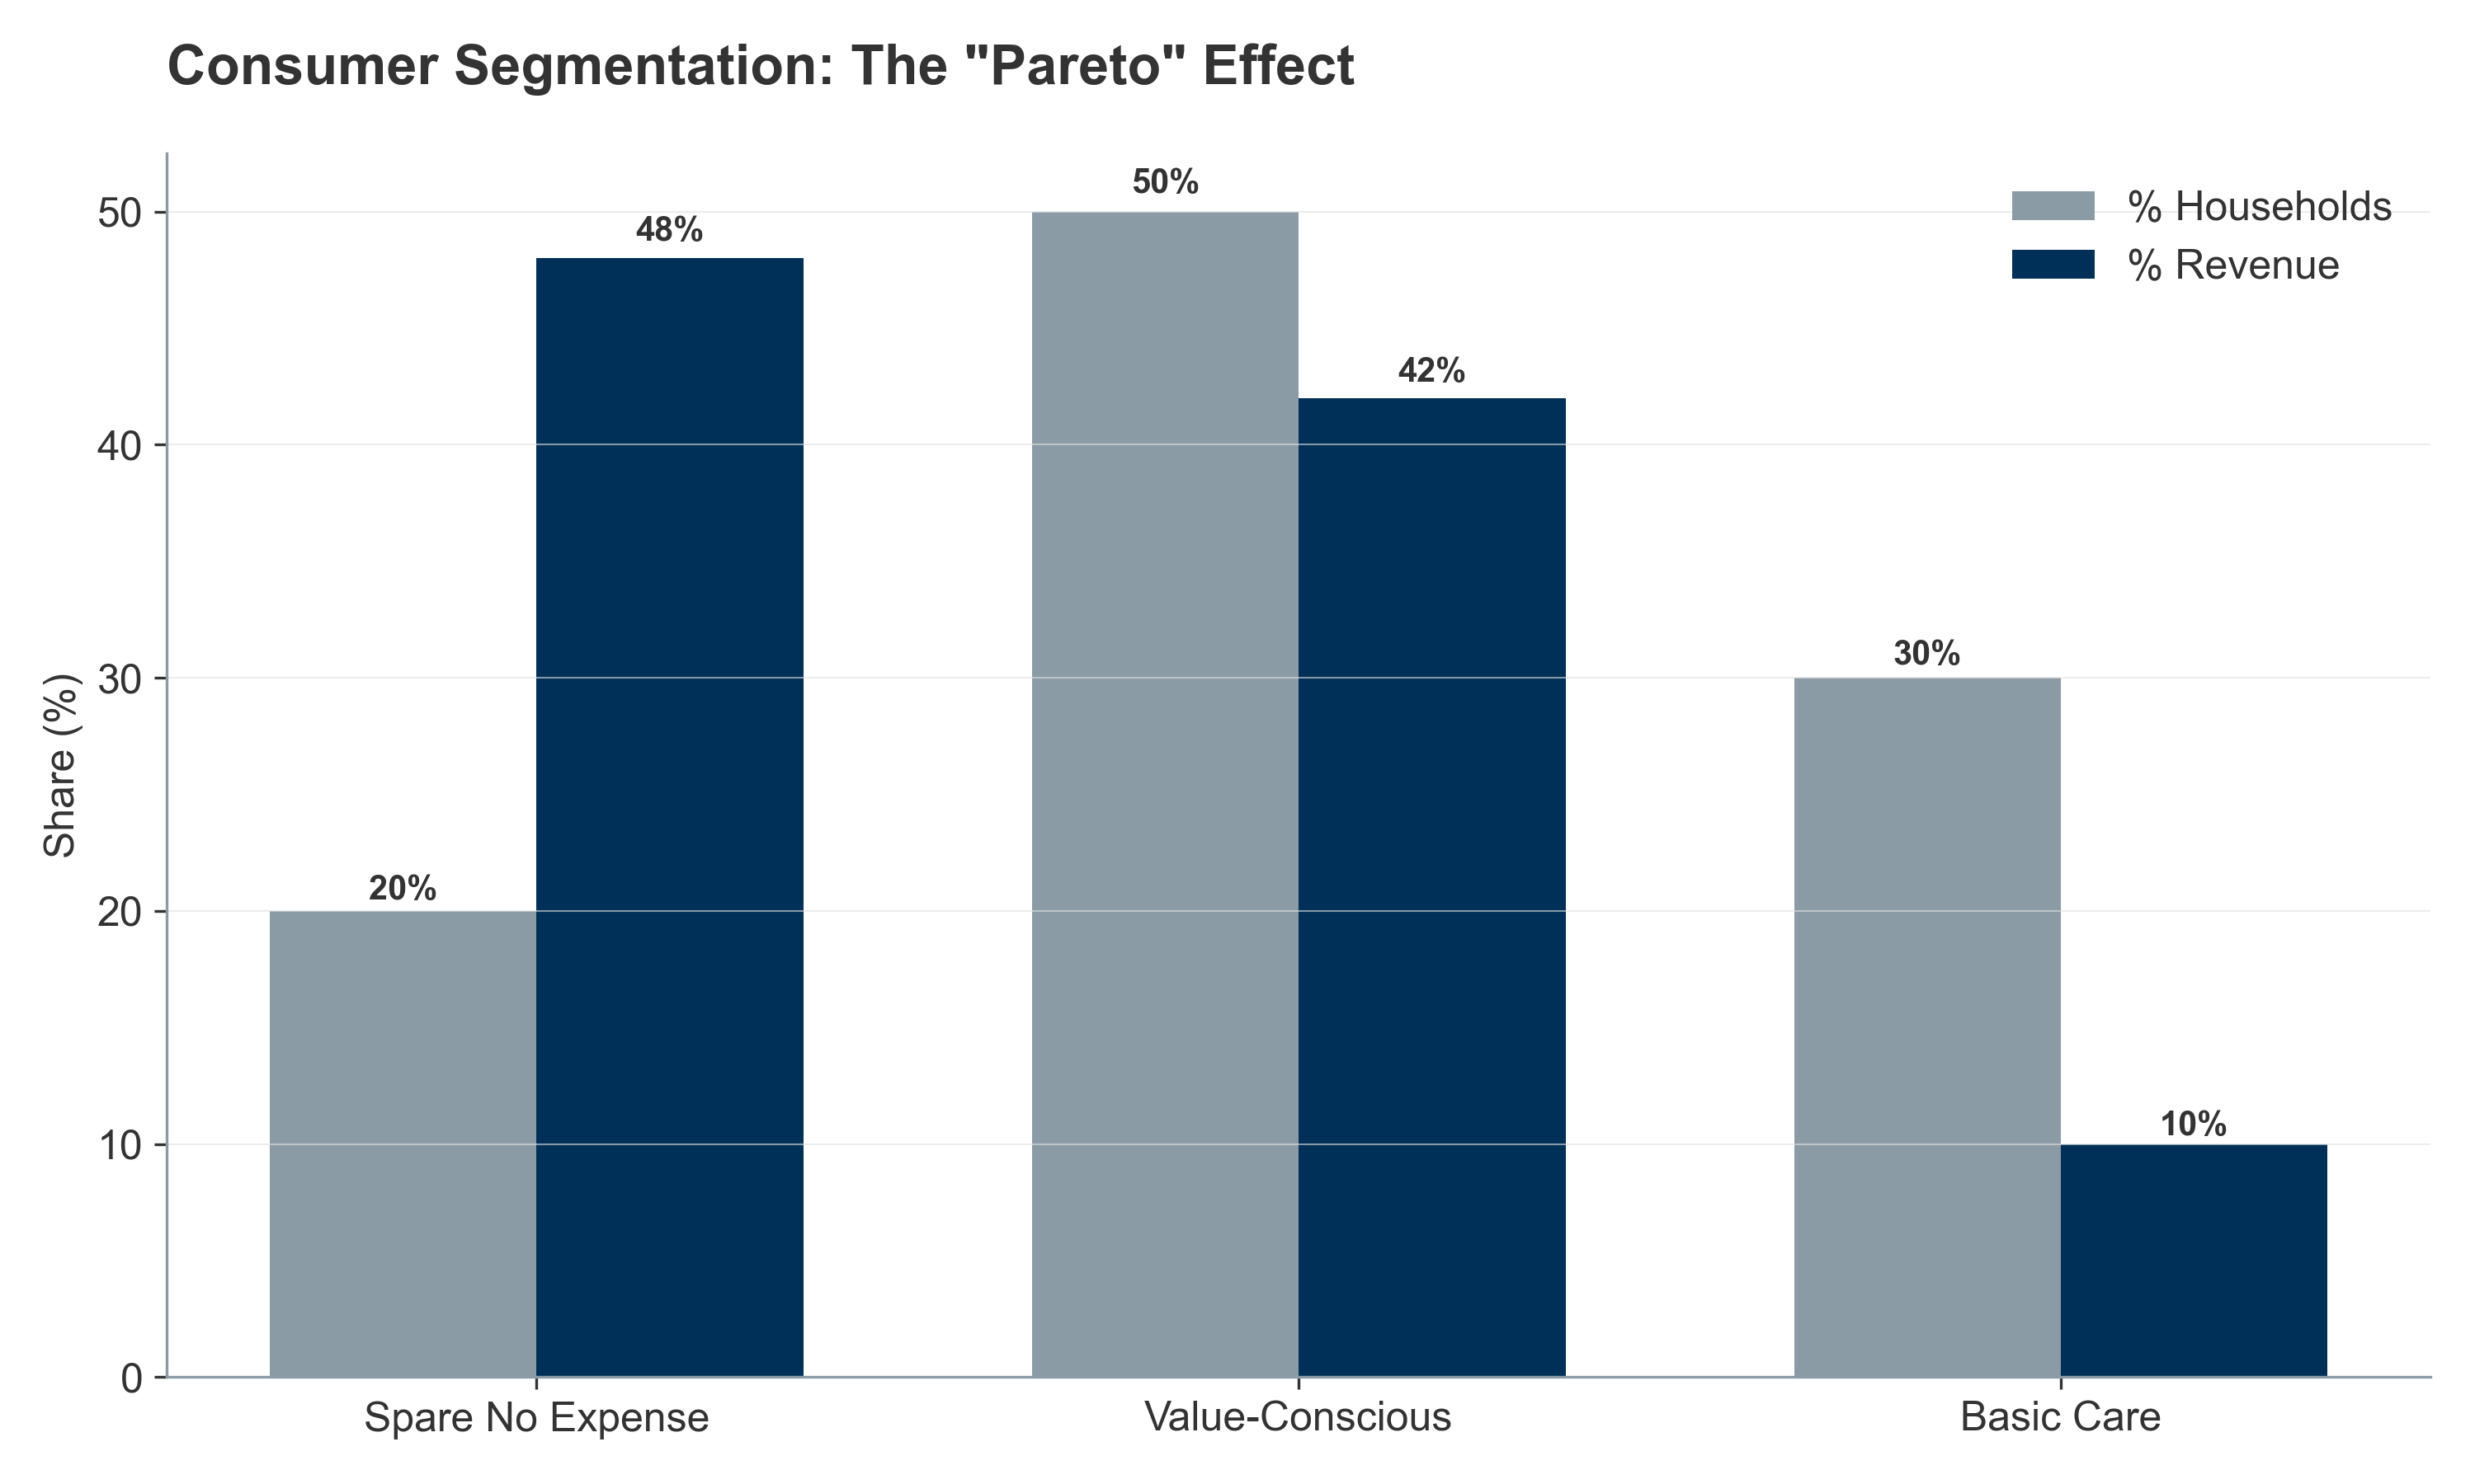 Source: Internal Customer Segmentation Logic*

***Figure 32: Nutraceuticals have captured a dominant share of the preventive care wallet.*** *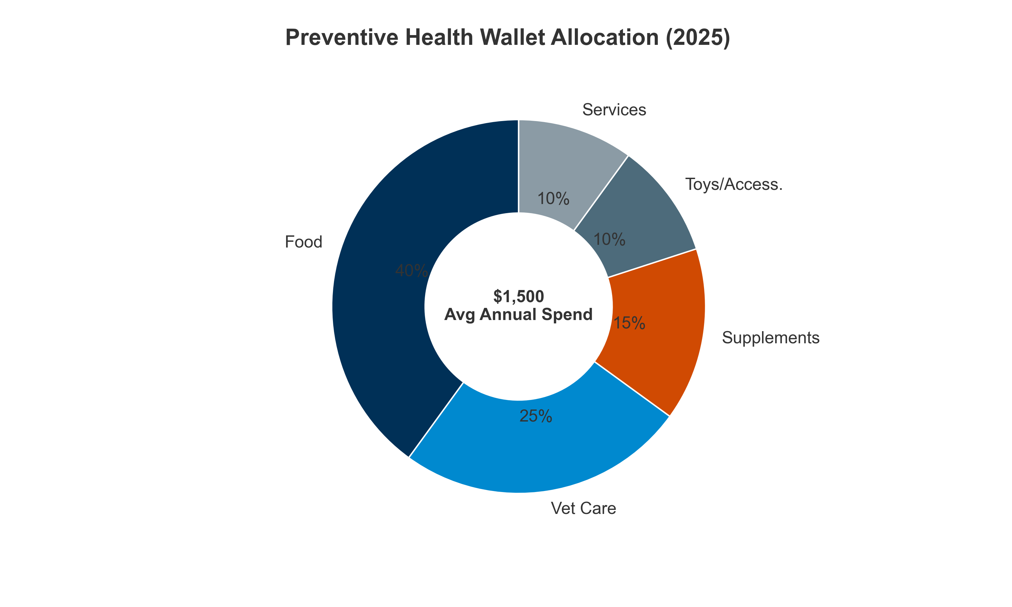 Source: APPA National Pet Owners Survey 2024*

***Figure 33: Category premiumization evolves from generic ingredients to IP-backed solutions.*** *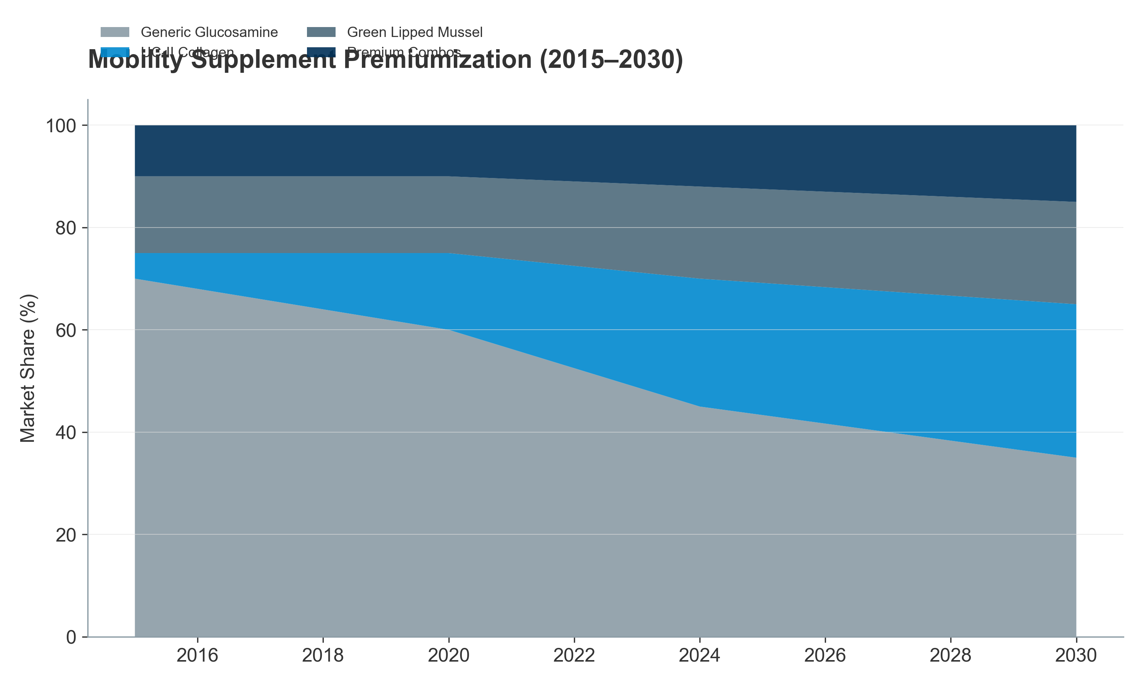 Source: Nutrition Business Journal (2024)*

***Figure 34: Determining validity of ‘Pre-Senior’ segment expands Customer Lifetime Value.*** *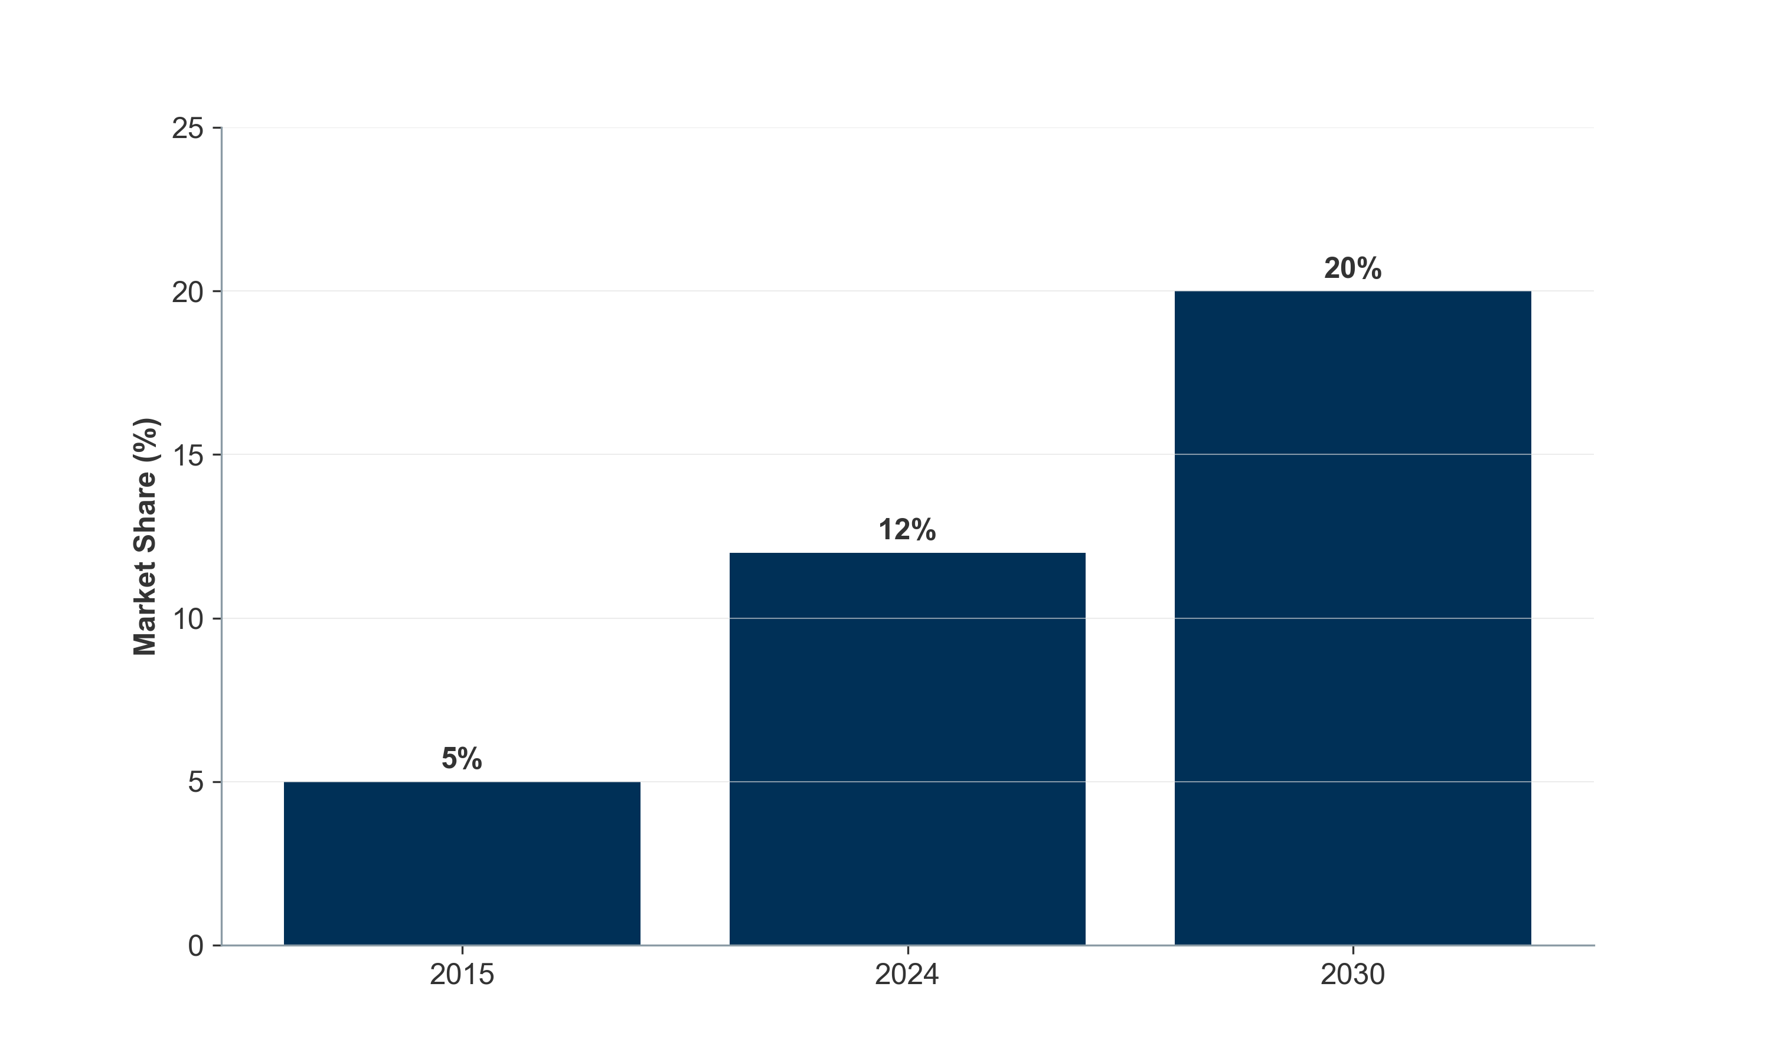 Source: Internal Lifecycle Analysis*

**Conclusion: Motivation Defines the Margin.** The psychology of spend confirms that margins are manufactured in the mind of the buyer. Whether driven by the fear of losing a companion or the risk of losing a herd, the highest value accrues to products that offer emotional or financial security.

# **PART III: The Value Chain Favours Vertical Integration**

Value is not distributed evenly; it aggregates at the extremes. Part III maps the “Barbell” structure of the industry, demonstrating how value flows away from the middle and towards Upstream IP Holders and Downstream Vertical Titans.

## **III.1. The Value Chain Privileges IP Holders**

**Margin Capture Depends on Position and IP Ownership.** The value chain is not a monolith; it is split between the “Speed” of Pet/Consumer and the “Scale” of Livestock/Industrial models. Our analysis of the “Value Waterfall” (Figure 35) reveals that pricing power erodes as products move downstream to generic retailers. The highest margins (**EBITDA 25–30%**) accrue to **Ingredient Suppliers** who hold the IP (e.g., DSM-Firmenich, Kemin). These entities are insulated from consumer fickleness and command pricing power through patent protection. Conversely, generic commodity suppliers are trapped in low-margin volatility (**5–12%**), confirming that IP is the primary hedge against commoditization.

***Figure 35: Pricing power erodes as products move from IP owners to generic retailers.*** *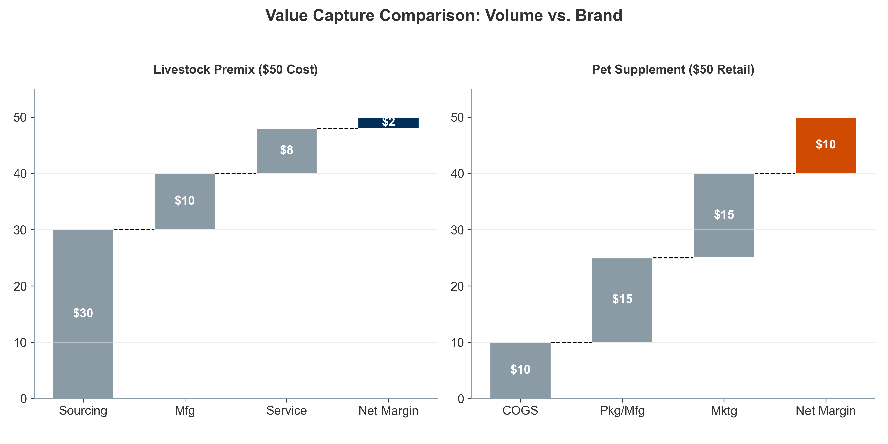 Source: Internal Pricing Model*

**Figure 36: Margin capture shifts upstream to IP holders and downstream to specialized CDMOs.** Margin capture shifts upstream to IP holders and downstream to specialized CDMOs. *Source: Internal Value Chain Analysis*

**Digital Platforms and CDMOs Reshape Distribution Economics.** The middle of the chain is evolving rapidly. **CDMOs** have emerged as hidden engines of value; with >60% of pet brands relying on third-party manufacturing, those commanding complex formats (like Soft Chews) enjoy **15–20% EBITDA** and high stickiness (Figure 36). On the retail front, while DTC offers theoretical margin capture, high Customer Acquisition Costs (CAC) often compress realized margins to **20–25%**, penalizing pure-play digital brands. The winning model is **Omnichannel Dominance**, which balances the reach of digital with the trust of veterinary and retail presence (Figure 37).

***Figure 37: Channel economics favor omnichannel dominance but penalize pure-play DTC.*** *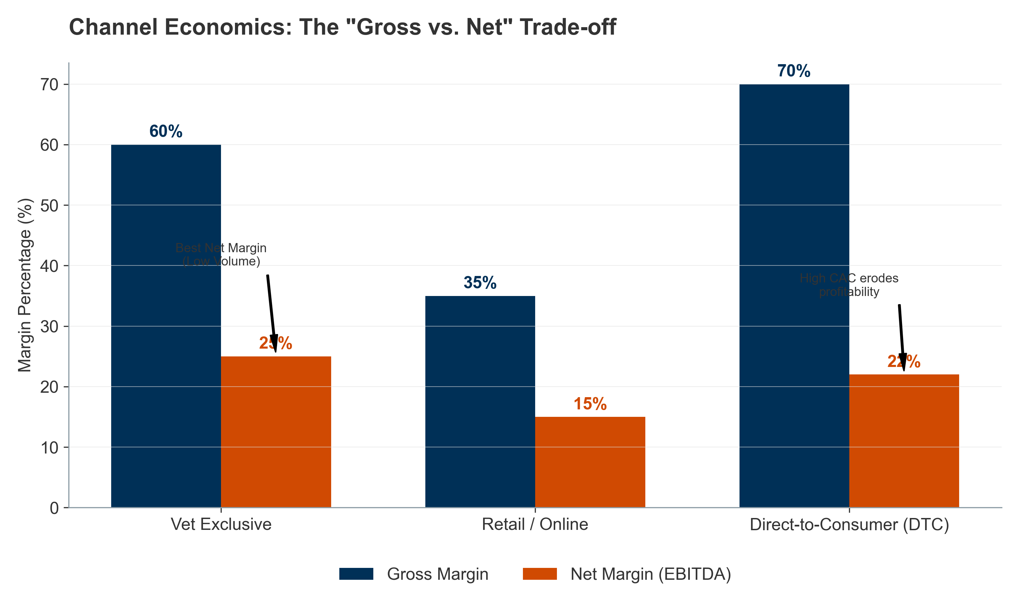 Source: Internal Channel Economics Model*

**Incumbents Use Nutraceuticals as a “Cradle-to-Grave” Funnel.** For major incumbents like Zoetis and Elanco, nutraceuticals are a strategic “Customer Acquisition Funnel” (Figure 38). By capturing the animal early with low-acuity wellness products, they secure the patient for high-value prescriptions later in the lifecycle. This “Cradle-to-Grave” monetization strategy denies competitors access to the veterinary channel and maximizes the lifetime value of the patient. Strategic categorization (Figure 39) clearly defines the risk-reward profile: incumbents acquire de-risked assets to feed this funnel, leaving high-risk R&D to smaller innovators.

***Figure 38: Incumbents utilize nutraceuticals as a low-cost acquisition funnel for future banking.*** *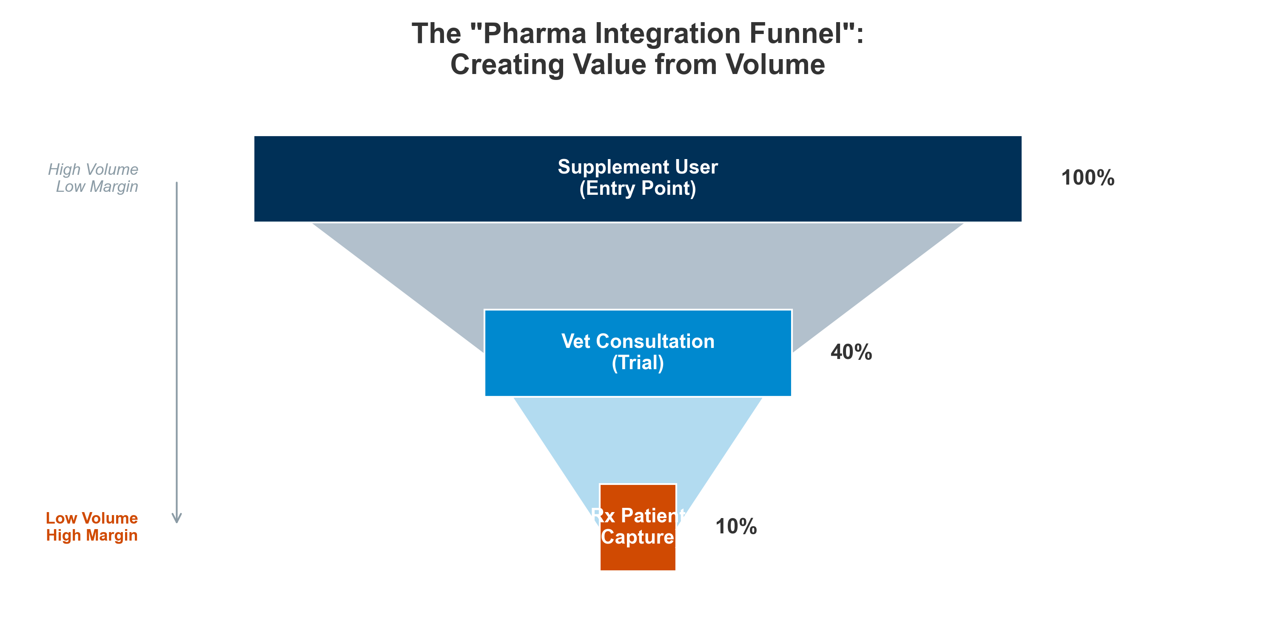 Source: Zoetis/Elanco Corporate Strategy Analysis*

***Figure 39: Strategic categorization defines the risk-reward profile for market entrants.*** *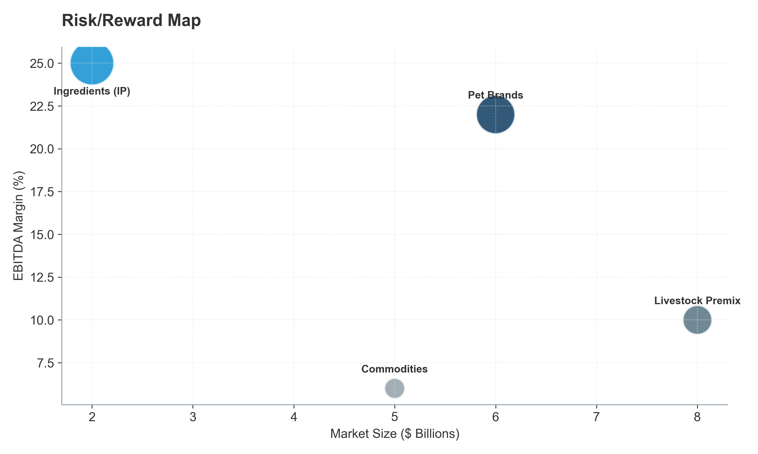 Source: Internal Strategic Categorization*

## **III.2. Consolidation Favors Vertical Titans**

**The “Barbell Structure” Defines the Competitive Landscape.** The industry has moved beyond fragmentation to a defined **“Barbell Structure”**: Massive, vertically integrated **Titans** (Zoetis, Mars) control the channels and the customer relationship, while agile **Innovators** (BiomEdit, Bond Pet Foods) control the biological IP. The “middle market”—populated by generic re-packagers without clinical differentiation—faces existential margin compression. Surviving this squeeze requires scale or science; there is no safety in the middle.

**M&A Has Replaced Internal R&D as the Primary Growth Engine.** For incumbents, R&D productivity has stalled while the cost to develop new molecules has skyrocketed (>$150M). Consequently, M&A has become the primary engine for innovation. Titans are paying **“Time-to-Market Premiums”** to acquire de-risked, clinically validated assets rather than building from scratch (Figure 40). The blueprint, exemplified by Zoetis, is to manage the entire **“Continuum of Care”** (Diagnostics $→$ Genetics $→$ Therapeutics $→$ Wellness), acquiring assets that plug gaps in this holistic loop.

***Figure 40: M&A valuation matrix favors de-risked assets over internal R&D development.*** *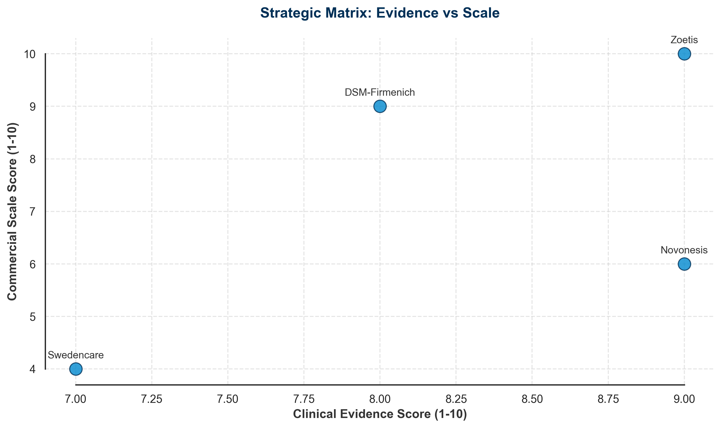 Source: Internal Deal Flow Analysis*

**Capital Markets Create Two Distinct Valuation Tiers.** Valuations reflect the bifurcation of the underlying assets (Table III.1). **Tier 1 (IP-Rich)** companies—those with patented molecules and clinical dossiers—trade at **16x–22x EBITDA**, as investors pay for the defensibility of the cash flow (e.g., Swedencare’s acquisition of NaturVet). **Tier 2 (Commodity)** brands, competing on price or generic ingredients, trade at **8x–11x EBITDA**. This arbitrage confirms that the market values **Moats over Revenue**: a smaller, protected revenue stream is worth more than a larger, commoditized one.

**Table III.1: Benchmark Transactions Define the Premium** | **Target** | **Acquirer** | **Deal Value** | **Implied Valuation** | **Strategic Rationale** | |:— |:— |:— |:— |:— | | **Zesty Paws** | H&H Group | **$610M** | **~16x EBITDA** | Omnichannel dominance + “Pet Humanization” brand equity. | | **NaturVet** | Swedencare | **$447M** | **~21.4x EBITDA** | Manufacturing capacity + Soft Chew IP ownership. | | **FoodScience** | MSCP | **Undisclosed** | **Premium** | Veterinary channel access (VetriScience brand). | | **Zoetis MFA** | Phibro | **$350M** | **Asset Sale** | Zoetis divestiture of low-margin/regulatory-risk assets. |

## **III.3. Deep Tech Defines the Future Frontier**

**Innovation Pivots from “Chemistry” to “Code”.** The next decade of value creation will be defined by **Biomanufacturing** and **Synthetic Biology**. Engineering biological logic—using microbes to programmatically express proteins—is replacing traditional extraction. Companies like **BiomEdit** (designing “living medicines”) and **Bond Pet Foods** (brewing nature-identical meat proteins) are proving that the future of nutrition is not grown in a field, but brewed in a tank. This shift from agriculture to fermenter-based production decouples the supply chain from climate volatility and ethical concerns.

**Methane Mitigation Creates a New Asset Class.** Climate policy is creating an entirely new asset class: **Methane Mitigation**. Technologies like **3-NOP (Bovaer)** are the regulatory gold standard, but challengers like **Rumin8** (bioactive oils) and **Symbrosia** (seaweed) are industrializing rapidly. This sector is unique because it sells “Compliance,” not “Nutrition.” As global dairy and beef chains commit to Net Zero, these additives become the “License to Operate,” guaranteeing demand independent of traditional productivity metrics.

**Longevity and Geroprotection represent the Final Frontier.** The ultimate expression of the “Humanization” thesis is **Longevity**. Owners are no longer satisfied with managing old age; they want to delay it. **Loyal (Cellular Longevity)** is pioneering FDA-approved drugs specifically for **Lifespan Extension** (LOY-001), signaling a paradigm shift where “Aging” becomes a treatable indication. Along with **Gallant’s** stem cell banking, these technologies suggest a future where the highest value nutraceuticals are those that fundamentally alter the biological clock.

**Conclusion: The New Asset Class is Defined by Technology.** The “Initiation of Coverage” verdict is definitive: Nutraceuticals have graduated from the “Wild West” to become the **Biological Infrastructure** of the global food and companion animal systems. Alpha generation now belongs to those who own the **Technology of Effectiveness**.

# **Appendices**

**A. Methodology & Data Sources** This report triangulates primary regulatory filings (FDA, EFSA, MARA) with corporate financial disclosures (10-K, Annual Reports) and scientific literature. Market sizing models account for the “Grey Zone” by strictly filtering for functional/active ingredients and excluding generic commodities.

**B. Key Industry Players** * **Zoetis:** The global standard for the “Continuum of Care”. * **DSM-Firmenich:** The leader in upstream nutritional IP and sustainability (Bovaer). * **Swedencare:** The aggregator of premium functional pet brands. * **Elanco:** The pure-play challenge in livestock efficiency. * **Purina / Mars:** The consumer giants defining the “Wellness” shelf.

**C. Regulatory Reference** * **US:** FDA GFI #293 (AFIA), Innovative FEED Act. * **EU:** Reg (EC) 1831/2003 (Zootechnical Additives). * **China:** MARA Decree 20 (Feed Additives Catalogue).

**Disclaimer** *This document is a strategic whitepaper simulating an Equity Research “Initiation of Coverage” report. It is for informational purposes only and does not constitute financial advice.*

**D. Comprehensive Industry Players & References**

**Key Market Players (Detailed)** | Company | Country | Category | Key Product/Focus | Target Species | Strategic Summary | | — | — | — | — | — | — | | **AB Vista** | UK | Livestock Feed | Econase XT | Poultry | Performance | | **Agrivida** | USA | Biotech | GraINzyme | Poultry | Corn-embedded enzymes | | **Alltech** | USA | Additives | Yea-Sacc | Multi | Yeast culture leader | | **Anizome** | UK/USA | Microbiome | Therapeutic Disc. | Multi | Microbiome therapeutics | | **AnimalBiome** | USA | Pet Health | FMT Capsules | Pet | Microbiome restoration | | **Axiota** | USA | Immunology | Multimin 90 | Cattle | Injectable minerals | | **Balchem** | USA | Encapsulation | ReaShure | Dairy | Choline precision delivery | | **BioAtla** | USA | Biotech | Conditional Antibodies | Pet | Oncology therapeutics | | **Biofeyn** | France | Aquaculture | Bio-encapsulation | Aqua | Nutrient delivery | | **BiomEdit** | USA | Synthetic Bio | Biome-Actives | Livestock | Living medicines | | **Bond Pet Foods** | USA | Biotech | Brewed Protein | Pet | Cruelty-free protein | | **Ceva** | France | Animal Health | Feliway | Pet | Pheromone behavior | | **Dechra** | UK | Pharma | Specific Diets | Pet | Therapeutic nutrition | | **DSM-Firmenich** | Swiss | Ingredients | Bovaer (3-NOP) | Ruminants | Methane reduction | | **Elanco** | USA | Pharma | Experior | Cattle | Ammonia reduction | | **Gnubiotics** | Swiss | Biotech | Glycans | Pet | HMO analogs | | **H&H Group** | HK | Consumer | Zesty Paws | Pet | Premium supplements | | **Hill’s** | USA | Pet Food | Prescription Diet | Pet | Clinical nutrition | | **Innovafeed** | France | Insect Protein | Black Soldier Fly | Aqua/Pet | Sustainable protein | | **Kemin** | USA | Ingredients | Betafin | Multi | Natural preservation | | **Loyal** | USA | Biotech | LOY-001 | Dog | Longevity metrics | | **Mars Petcare** | USA | Conglomerate | Royal Canin | Pet | Health nutrition | | **MicroHarvest** | Germany | Biotech | Single Cell Protein | Aqua/Pet | Fast protein | | **Mootral** | Swiss | AgTech | Mootral Ruminant | Cattle | Natural methane red. | | **Native Microbials**| USA | Biotech | Galaxis | Dairy | Rumen native microbes | | **Native Pet** | USA | Consumer | Clean Label | Pet | Minimalist supplements | | **Nestlé Purina** | Swiss | Conglomerate | Pro Plan | Pet | Fortified nutrition | | **Novonesis** | Denmark | Biosolutions | Probiotics | Multi | Enzyme/Microbe leader | | **Nutramax** | USA | Consumer | Cosequin | Pet | Joint health standard | | **Phibro** | USA | Additives | OmniGen | Dairy | Immunity | | **Phytobiotics** | Germany | Additives | Sangrovit | Swine | Phytogenic inflammation | | **Proteon** | Poland | Biotech | BAFASAL | Poultry | Bacteriophages | | **Roquette** | France | Ingredients | Pea Protein | Multi | Plant-based ingredients | | **Rumin8** | Australia| Climate Tech | Methane Reducer | Cattle | Oil-based delivery | | **Swedencare** | Sweden | Consumer | ProDen PlaqueOff | Pet | Oral health patent | | **Symbrosia** | USA | Climate Tech | SeaGraze | Cattle | Seaweed methane red. | | **Symrise** | Germany | Ingredients | Palatability | Pet | Taste/Flavor | | **Vetoquinol** | France | Pharma | Flexadin | Pet | Joint supports | | **Veramaris** | Dutch | Ingredients | Algal Oil | Aqua/Pet | Sustainable Omega-3 | | **Vetnique** | USA | Consumer | Glandex | Pet | Anal gland health | | **Virbac** | France | Pharma | HPM Diets | Pet | Veterinary nutrition | | **Wild Earth** | USA | Consumer | Koji Protein | Pet | Fungi-based protein | | **YuMOVE** | UK | Consumer | Mobility Chews | Pet | Clinical joint leader | | **Zesty Paws** | USA | Consumer | Multifunctional | Pet | E-commerce leader | | **Zoetis** | USA | Pharma | Clarify (Dx) | Multi | Continuum of care |

**Comprehensive References & Market Data**

**Market Intelligence Sources:** * **Grand View Research.** (2024). *Animal Health Market Size & Share Analysis Report, 2030.* * **Euromonitor International.** (2024). *Pet Care Global Market Data 2024.* * **Nutrition Business Journal (NBJ).** (2023). *Supplement Business Report 2023.* * **Future Market Insights.** (2024). *Animal Feed Additives Market Outlook.* * **MarketsandMarkets.** (2023). *Probiotics in Animal Feed Market - Global Forecast to 2028.* * **FEDIAF.** (2024). *European Pet Food Industry: Facts & Figures 2023.* * **American Pet Products Association (APPA).** (2024). *National Pet Owners Survey (2023-2024).* * **FAO (Food and Agriculture Organization).** (2024). *The State of World Fisheries and Aquaculture (SOFIA) 2024.* * **Eurostat.** (2024). *Agricultural Production - Livestock and Meat (2023 Data).* * **Mordor Intelligence.** (2024). *Global Animal Nutraceuticals Market Size & Share Analysis.*

**Consumer Psychology & Scientific Literature:** * **Nicotra, M., et al.** (2025). “Nutraceuticals, Social Interaction, and Psychophysiological Influence on Pet Health and Well-Being.” *Veterinary Sciences* 12.10: 964. * **Roush, J. K., et al.** (2010). “Multicenter veterinary practice assessment of the effects of omega-3 fatty acids on osteoarthritis in dogs.” *JAVMA*. * **Gupta, R. C., et al.** (2012). “Comparative therapeutic efficacy and safety of type-II collagen (UC-II)…” *J. Anim. Physiol. Anim. Nutr.* * **Vandeweerd, J. M., et al.** (2012). “Systematic review of efficacy of nutraceuticals to alleviate clinical signs of osteoarthritis.” *JVIM*. * **Comblain, F., et al.** (2016). “Review of dietary supplements for the management of osteoarthritis in dogs.” *Critical Reviews in Food Science and Nutrition*. * **Kelley, R. L., et al.** (2009). “Clinical efficacy of probiotics in the treatment of acute diarrhea in dogs.” *JVIM*. * **Cowieson, A. J., et al.** (2020). “Phytase in animal nutrition and its efficacy.” *Animal Production Science*.

**Corporate Filings (2023-2025):** * **Zoetis Inc.** (Form 10-K). * **Elanco Animal Health** (Investor Presentations). * **DSM-Firmenich** (Integrated Annual Report). * **Nestlé Purina** (Creating Shared Value). * **Swedencare** (Year-End Report). * **Virbac** (Annual Financial Report). * **Dechra Pharmaceuticals** (Annual Report).

# **Summary of Figure Adjustments**

| **Original File** | **New Number** | **Key Takeaway** |
| --- | --- | --- |
| Table_US_vs_EU.png | Figure 1 | Regulatory Divergence creates structural barriers to entry for non-compliant actors. |
| Timeline_Regulations.png | Figure 2 | Regulatory accelerators like AGP bans have historically driven volume adoption. |
| Figure_I_3_Regulatory_Matrix.png | Figure 3 | Regulatory pathways dictate unit economics and allowable claims. |
| Figure_TAM_Reconciliation.png | Figure 4 | Market reconciliation excludes commodities to define the investable high-value universe. |
| Matrix_Species_Functional.png | Figure 5 | Functional architecture maps biological needs to commercial opportunities. |
| Figure_II_0_1_Innovation_Matrix.png | Figure 6 | R&D intensity correlates directly with EBITDA margin expansion/premium. |
| Figure_II_0_2_Market_Bifurcation.png | Figure 7 | Structural bifurcation splits the market into Emotional (Pet) and ROI (Livestock) economies. |
| Figure_II_1_Matrix.png | Figure 8 | Efficacy levels in Mobility define market positioning and pricing power. |
| Figure_II_2_Matrix.png | Figure 9 | Gut Health strategy shifts from generic digestion to precision microbiome modulation. |
| Figure_II_3_Matrix.png | Figure 10 | Immunity solutions build biological resilience for the post-antibiotic era. |
| Figure_II_4_Matrix.png | Figure 11 | Cognitive support monetizes the Silver Economy via neuro-preservation. |
| Figure_II_5_Matrix.png | Figure 12 | Non-sedative anxiolysis replaces pharmacological interventions in behavior management. |
| Figure_II_6_Matrix.png | Figure 13 | Enzymes and yeast cultures drive Feed Conversion Ratios (FCR) in livestock. |
| Figure_II_7_Matrix.png | Figure 14 | Visual health attributes like pigmentation and dermatology command functional premiums. |
| Figure_II_8_Matrix.png | Figure 15 | Safety appeal drives the adoption of natural repellents over chemical actives. |
| Figure_II_9_Matrix.png | Figure 16 | Gene-expression data constructs a defensible moat of validation around ingredients. |
| Figure_II_10_Matrix.png | Figure 17 | Advanced delivery formats ensure bioavailability and maximize compliance. |
| Figure_II_11_Matrix.png | Figure 18 | Sustainability metrics like methane reduction are becoming non-negotiable procurement specs. |
| Figure1_Pet_Ownership.png | Figure 19 | Developed markets prioritize ‘Value over Volume’ in pet ownership trends. |
| Figure2_EU_Pet_Pop.png | Figure 20 | European demographics show a structural dominance of the feline segment. |
| Figure3_EU_Growth.png | Figure 21 | Feline segment growth outpaces canine due to urbanization constraints. |
| Figure4_Regional_Market.png | Figure 22 | APAC emerging as the primary volume engine for the next decade. |
| Figure9_Livestock_Trends.png | Figure 23 | Global protein production shifts favor poultry and aquaculture over ruminants. |
| Figure5_Probiotics_Share.png | Figure 24 | Probiotics volume share reflects the dominance of poultry and swine sectors. |
| Figure6_Poultry_HPAI.png | Figure 25 | Disease outbreaks act as catalysts for immune-modulating additive demand. |
| Figure7_Swine_Decline.png | Figure 26 | Regulatory pressures drive structural contraction in Western swine herds. |
| Figure8_Cattle_Inventory.png | Figure 27 | Western de-ruminization shifts value from herd size to efficiency-per-head. |
| Figure11_Aquaculture_Production.png | Figure 28 | The ‘Blue Transformation’ drives industrialization and functional additive needs in aqua. |
| Figure14_Psychology.png | Figure 29 | Purchasing psychology is driven more by the fear of loss than aspirational health. |
| Figure11_Formats.png | Figure 30 | Palatability and format dictate compliance, which is a key efficacy driver. |
| Figure13_Segmentation.png | Figure 31 | High-spending households drive the majority of revenue in the pet wellness category. |
| Figure12_Wallet.png | Figure 32 | Nutraceuticals have captured a dominant share of the preventive care wallet. |
| Figure15_Mobility_Evo.png | Figure 33 | Category premiumization evolves from generic ingredients to IP-backed solutions. |
| Figure16_Senior_Growth.png | Figure 34 | Determining validity of ‘Pre-Senior’ segment expands Customer Lifetime Value. |
| Figure19_Value_Waterfall.png | Figure 35 | Pricing power erodes as products move from IP owners to generic retailers. |
| Figure17_Value_Chain.png | Figure 36 | Margin capture shifts upstream to IP holders and downstream to specialized CDMOs. |
| Figure18_Channel_Economics.png | Figure 37 | Channel economics favor omnichannel dominance but penalize pure-play DTC. |
| Figure21_Pharma_Funnel.png | Figure 38 | Incumbents utilize nutraceuticals as a low-cost acquisition funnel for future banking. |
| Figure20_Risk_Reward.png | Figure 39 | Strategic categorization defines the risk-reward profile for market entrants. |
| Figure_MA_Matrix.png | Figure 40 | M&A valuation matrix favors de-risked assets over internal R&D development. |